A project report
o n
Car Rental Management System

Submitted to MDS University, Ajmer for the Partial Fulfillment of the requirement of the award of degree for
Bachelor In Computer Applications
(BCA)
Session : 2024 - 2025

Developed by : Submitted by : Guided by :
rathore BCA 3rd Year

CERTIFICATE

This is certify that the project work entitled “Car Rental Management System” submitted in Partial fulfillment of requirement of the degree of BCA (MDS University, Ajmer) at Star Infotech College, Ajmer done by khushboo rawat, Enrollment no. 2022/3826 is an authentic work carried out by him/her under the supervision.
The matter embedded in this project work has not been submitted for the award of any other examination.

rathore
(Project Guide)

ACKNOWLEDGEMENT

I express thanks and gratitude to almighty God, my parents and other family members without whose support I could not have made this software project. I wish to place on my record my deep sense, Mr./Ms. Rahul singh rathore for his/her constant motivation and valuable help throughout the project work. I also extend my thanks to other faculty members for their cooperation during this course.

Last but not least, I thankful to my all friends for their support for completing this project.

Khushboo rawat

C o n t e n t s

Introduction
Platform used
Front & Back end used
Project Analysis
Feasibility study
Project design
Table Structure
Form Design
Coding
Bibliography

INTRODUCTION

A Car Rental Management System is a robust, web-based application that serves as a one-stop solution for car rental businesses. It is developed using a combination of several web technologies, including PHP, HTML, CSS, JavaScript, and SQL.

The system is designed to streamline the operations of car rental businesses. It provides a platform where car rental companies can list their vehicles, and customers can view these listings and book vehicles as per their requirements. The system aims to simplify the process of car rentals, making it more efficient and user-friendly.

The system is divided into two main modules:

- User Module: This module is designed for registered users. Once users log in with their valid email and password, they can book cars as per their requirements. They can also view their booking history, which provides them with details of all their past bookings. Users can update their profile and password as needed. Additionally, they can post testimonials, sharing their experiences and feedback about the service.

- Admin Module: This module is designed for the administrators of the website. The admin has complete control over the website and can manage all its aspects. They can manage vehicle brands and individual vehicles, ensuring that all the listings on the website are up-to-date. They can also manage bookings, keeping track of all the bookings made through the website. The admin can manage testimonials, reviewing the feedback provided by users. They can manage queries received through the contact us page, ensuring that all user inquiries are addressed. The admin can also manage the content of the pages, the contact details displayed on the website, the subscribers of the newsletter, and the registered users.

The user interface of the system is designed using HTML, CSS, JQUERY, and JAVASCRIPT. These technologies ensure that the interface is interactive and user-friendly. PHP is used as the server-side language. It handles all the server-side processing, including user authentication, data validation, and session management.

The backend database used is MySQL. All the data related to users, cars, bookings, etc., are stored in this database. SQL is used to manage and manipulate this data. SQL queries are used to interact with the database, performing operations like inserting new data, updating existing data, retrieving data, and deleting data.

In conclusion, the Car Rental Management System is a comprehensive solution for car rental businesses. It leverages modern web technologies to provide a streamlined, efficient, and user-friendly platform for managing car rental operations. It is a great example of how PHP, HTML, CSS, JavaScript, and SQL can be integrated to build robust and efficient business applications. This system not only simplifies the process of car rentals but also improves the efficiency of the operations and the user experience.
PLATFORM USED

In this Project I have used various elements , basically it is based on PHP,with that HTML , CSS , Bootstrap , Jquery.

PHP stands for Hypertext Preprocessor (no, the acronym doesn't follow the name). It's an open source, server-side, scripting language used for the development of Ib applications. By scripting language, I mean a program that is script-based (lines of code) written for the automation of tasks.
Ib pages can be designed using HTML. With HTML, code execution is done on the user's browser (client-side). On the other hand, with PHP server-side scripting language, it's executed on the server before it gets to the Ib browser of the user.
PHP can be embedded in HTML, and it's Ill suited for Ib development and the creation of dynamic Ib pages for Ib applications, e-commerce applications, and database applications. It's considered a friendly language with abilities to easily connect with MySQL, Oracle, and other databases.
Features Of PHP
- PHP can generate dynamic page content
- PHP can create, open, read, write, delete, and close files on the server
- PHP can collect form data
- PHP can send and receive cookies
- PHP can add, delete, modify data in your database
- PHP can be used to control user-access
- PHP can encrypt data
Features of MySQL
- MySQL is a database system used on the Ib
- MySQL is a database system that runs on a server
- MySQL is ideal for both small and large applications
- MySQL is very fast, reliable, and easy to use
- MySQL uses standard SQL
FRONT END AND BACK END USED
Here front end is created with combination of multiple Elements.Such as HTML , CSS , Bootstrap , Jquery.
HTML is the standard markup language for creating Ib pages.
- HTML stands for Hyper Text Markup Language.
- HTML describes the structure of a Ib page.
- HTML consists of a series of elements.
- HTML elements tell the browser how to display the content.
- HTML elements are represented by tags.
- HTML tags label pieces of content such as "heading", "paragraph", "table", and so on.
- Browsers do not display the HTML tags, but use them to render the content of the page.
CSS stands for Cascading Style Sheets.
- CSS describes how HTML elements are to be displayed on screen, paper, or in other media.
- CSS saves a lot of work. It can control the layout of multiple Ib pages all at once.
- External stylesheets are stored in CSS files.
Bootstrap
- Bootstrap is a free front-end framework for faster and easier Ib development.
- Bootstrap includes HTML and CSS based design templates for typography, forms, buttons, tables, navigation, modals, image carousels and many other, as Ill as optional JavaScript plugins.
- Bootstrap also gives you the ability to easily create responsive designs.
Jquery
- jQuery is a lightIight, "write less, do more", JavaScript library.
- The purpose of jQuery is to make it much easier to use JavaScript on your Ibsite.
- jQuery takes a lot of common tasks that require many lines of JavaScript code to accomplish, and wraps them into methods that you can call with a single line of code.
- jQuery also simplifies a lot of the complicated things from JavaScript, like AJAX calls and DOM manipulation.
For Backend
PHP is used to control every backend work such as Database related task.All DML operations such as Insert , Update , Delete , Image Uploading , Image Removal , Records shown on Pages is also using Php Functionalities.
For Connecting To Database I have used PDO.
PDO refers to PHP Data Object, which is a PHP extension that defines a lightIight and consistent interface for accessing a database in PHP. It is a set of PHP extensions which provide a core PDO class and database-specific driver. Each database driver can expose database-specific features as a regular extension function that implements the PDO interface.
PDO mainly focuses on data access abstraction rather than database abstraction. It provides data-access abstraction layer, which means, regardless of which database I are using, I have to use the same functions provided by that database to issue queries and fetch data. PDO does not provide data abstraction, as it does not rewrite the SQL or emulate missing features.
There are some advantages of PDO as follows:
- Database support
The PDO extension can access any database which is written for PDO driver. There are several PDO drivers available which are used for FreeTDS, Microsoft SQL Server, Sybase, IBM DB2, Oracle Call Interface, Firebird/Interbase 6, and PostgreSQL databases, among many more.
- Database connecting
There are different syntaxes available to establish the database connection.
- Error handling
PDO permits to use exceptions for error handling. There are three error modes, i.e., Silent (default), Warning, and Exception. Warning and Exception are more useful in DRY programming.
- Insert and Update
PDO reduces the commonly used insert and update database operation into a two-step process, i.e.
Prepare >> [Bind] >> Execute.
Through this method, I can take full advantage of PDO's prepared statements, which protect against malicious attacks through SQL injection.

PROJECT ANALYSIS

An online Car Rental Management System that allows users to check for various cars available at the online store and book online. The project consists of a list of cars displayed in various categories. The user may browse through these items as per categories. If the user likes a car, he may add it to his booking cart. Once the user wishes to checkout, he must register on the site first. He can then log in using the same id password next time. Now he may pay through a credit card or cash on delivery. Once the user makes a successful transaction, he gets a copy of the booking receipt on his email id. Here I use a user-friendly interface to make the entire frontend. The middle tier or code behind the model is designed for fast processing. And SQL serves as a backend to store car lists data. Thus, the online Car Rental Management System project brings an entire car rental business online and makes it easy for both renter and customer.

Modules: -
• User Registration: User can register on the system and get his online account on site.
• User Login: User can log in to the system and check various cars.
• Car Categories: The cars are arranged and can be viewed in categories.
• Add to cart: Users can add new items to cart.
• Dummy Payment: After the total bill is calculated, the user can pay via credit card online. (Yet Not Added)
• Email confirmation: On successful payment, a thank you message is sent to the user. (Yet Not Added)

Applications: -
• This system can be used in single Car Rental businesses.
• This system can be used to sell like a chain of Car Rental businesses from a single site.

Software Requirements: -
• On Any Browser
• Proper Internet
• Wamp Server (Till Not launched)
FEASABILITY STUDY

1.Financial Feasability :
Being a web application with no cost of any component added in this project.All open source elements are used in this project.Such as HTML, CSS, PHP, Bootstrap, Jquery etc.
No such financial feasablility.
2.Technical Feasablility :
This is a Web Application , hence all technical tools used to create this are different Languages elements :
- HTML(Hypertext Markup Language).
- CSS(Cascading Style Sheet).
- Bootstrap Library Files.
- Wamp Server.
- Editor to develop this project.Such as Notepad++, Sublime Text 3,Visual Studio etc.
- Knowledge of all components To implement concept.
- Browser to run Application.
- Internet Connection.

3.Legal Feasability :
This is required or matters while launching this project to public portal.
4.Operational Feasability :
This project fill almost all basic needs which a E-commerce Site requires.Such as view to products, likes to products, payment management, product management, user management etc.
5.Schedule Feasability :
This project is scheduled to be completed in 1 months approx.As it has various operational control it has a reasonable time requirement.
PROJECT DESIGN
User Views
1.Home Page
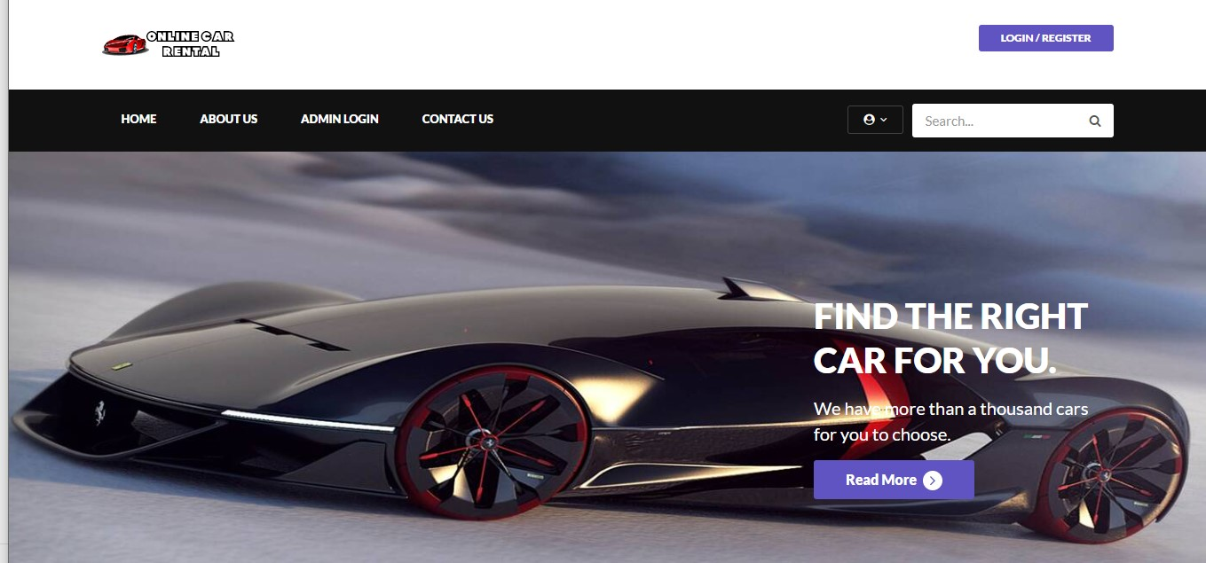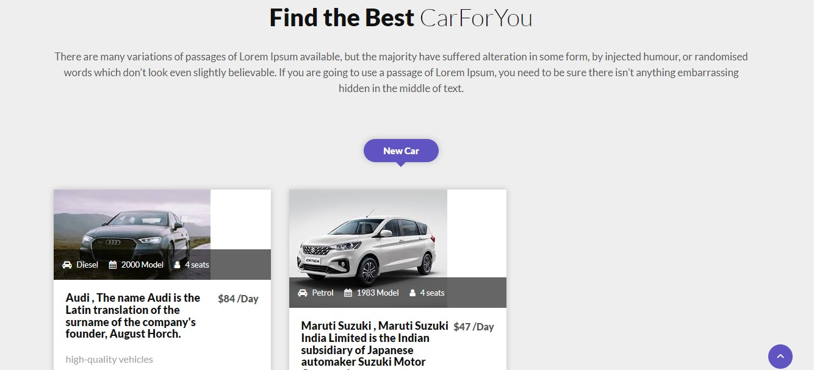

2.About Us Page

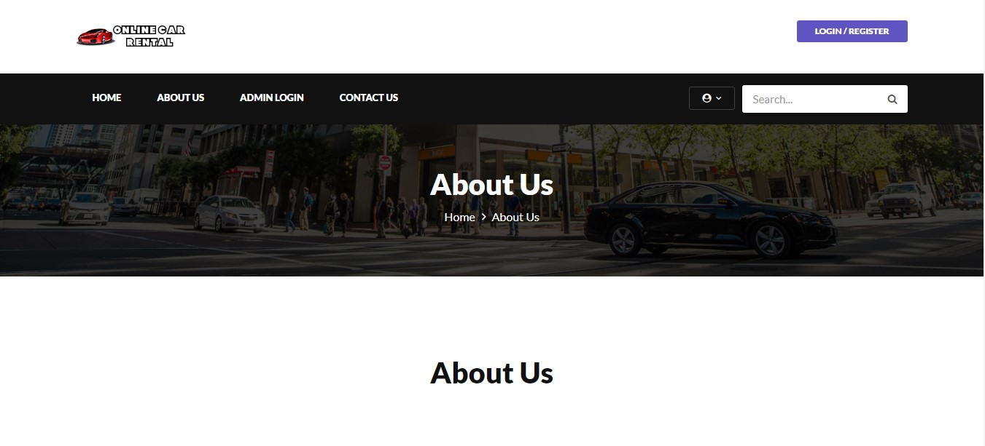
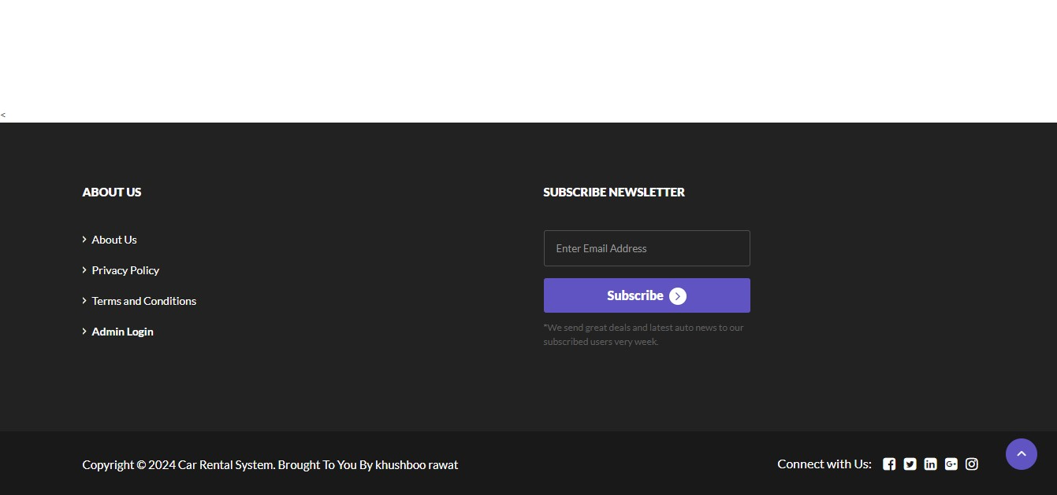

3.Shop Page

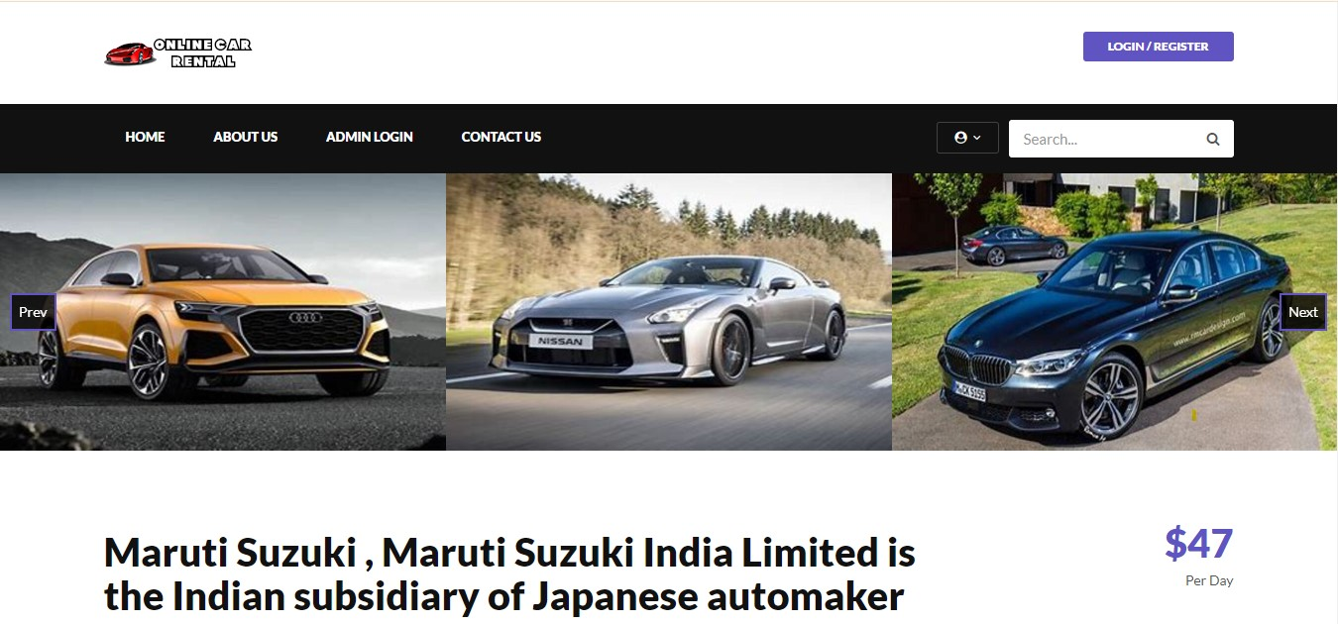
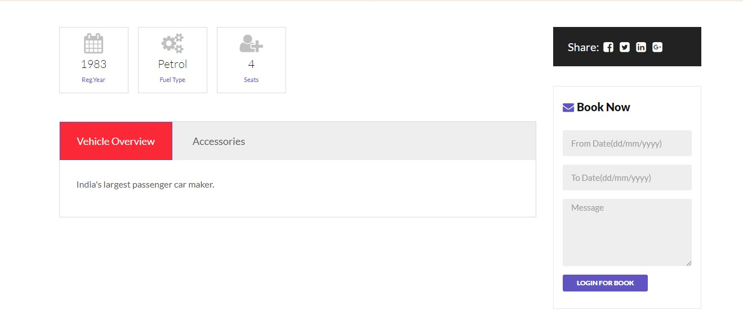4.Contact Page

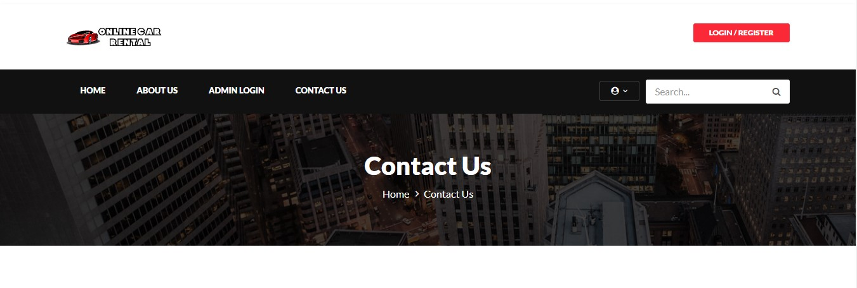
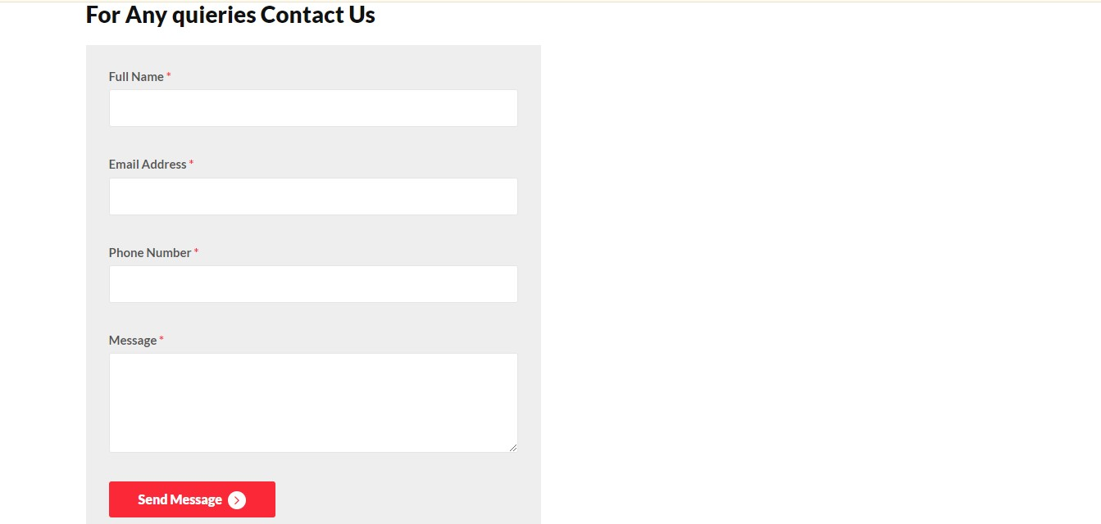

Admin View
- Home Page
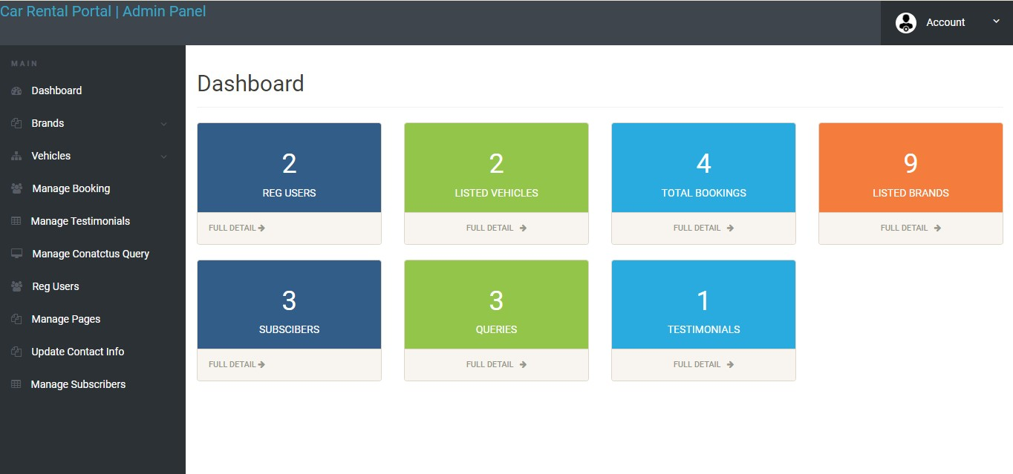

2. Manage Bookings Page
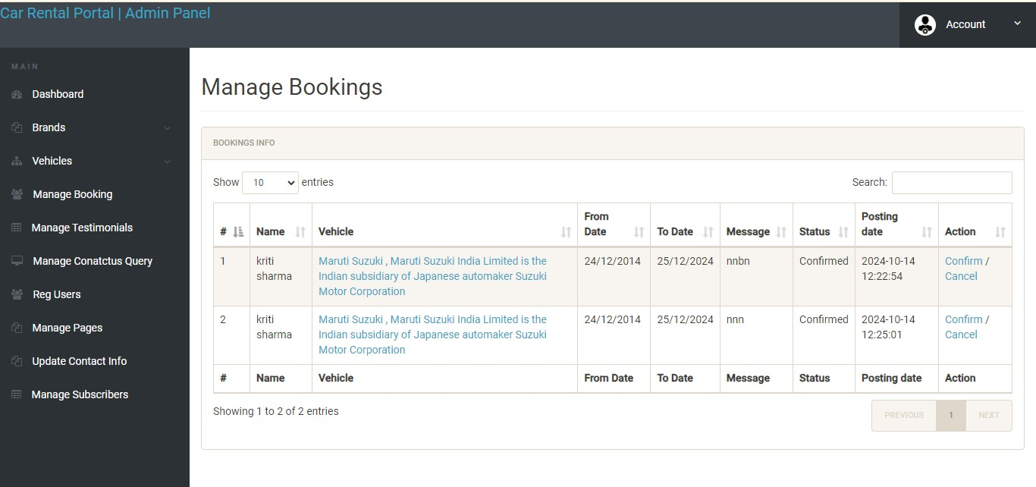

3. Manage Contact Us Queries
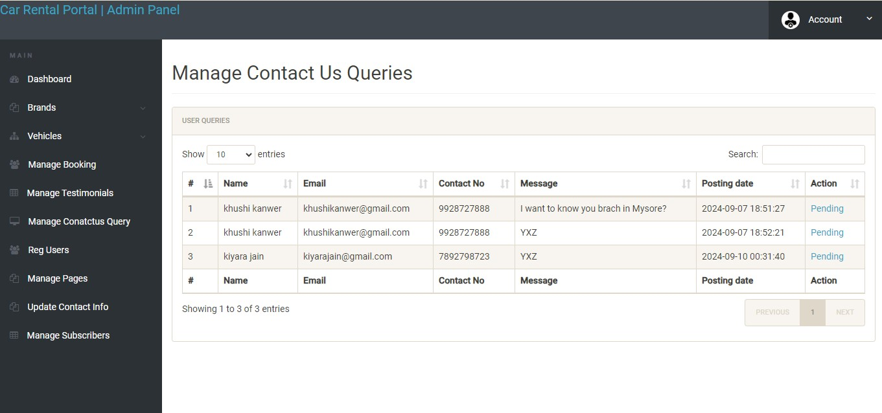

Tables Structure
1.Admin

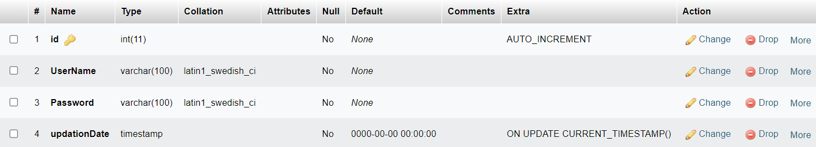

2. Booking
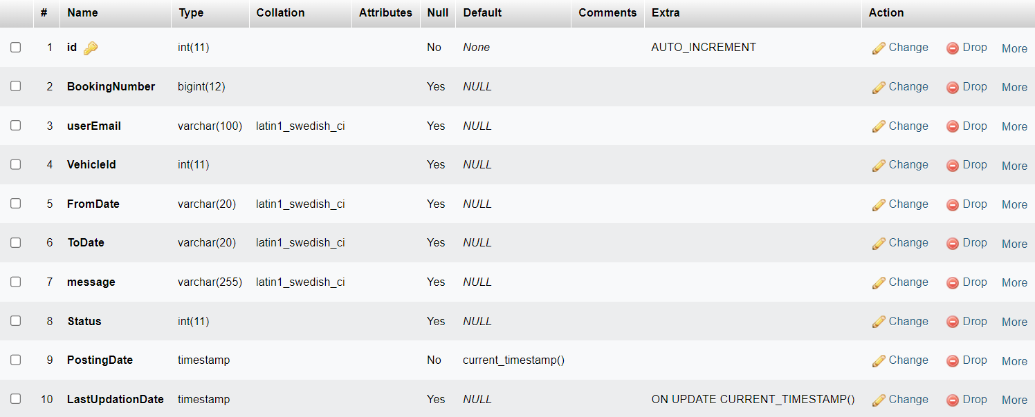

3. Brands
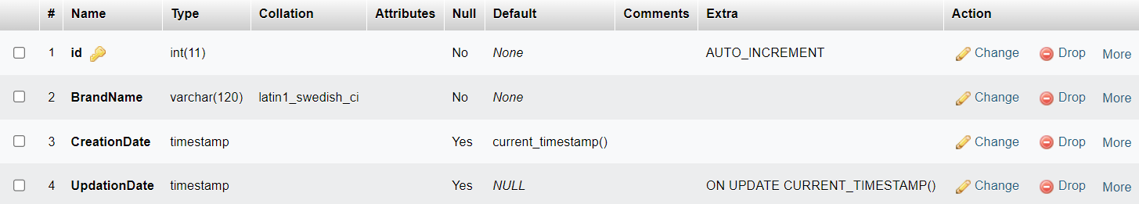

4. Contact Us
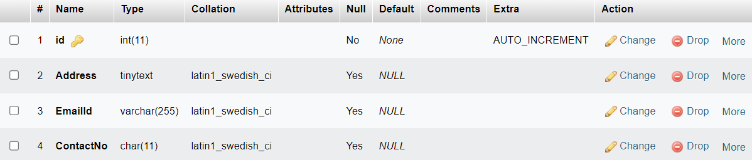
5. Contact Us Query
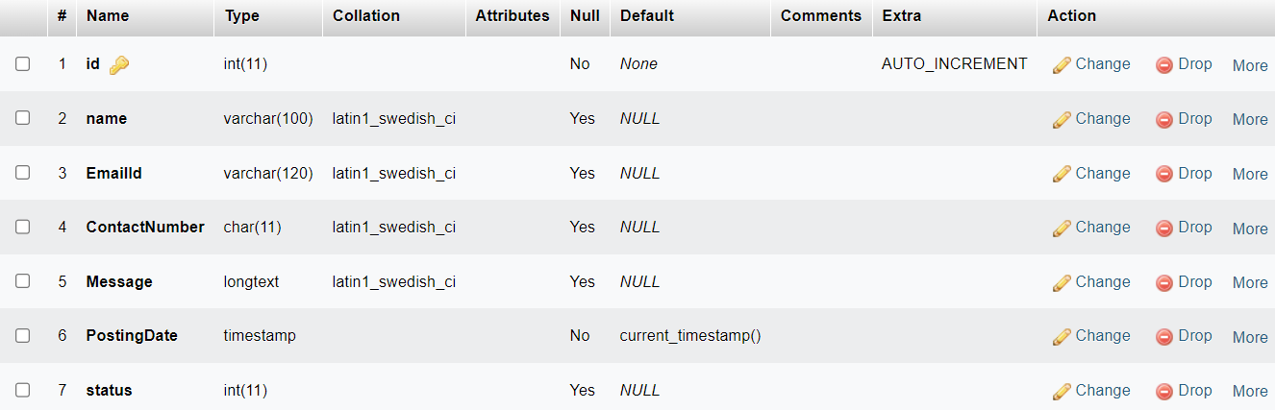

6. Pages
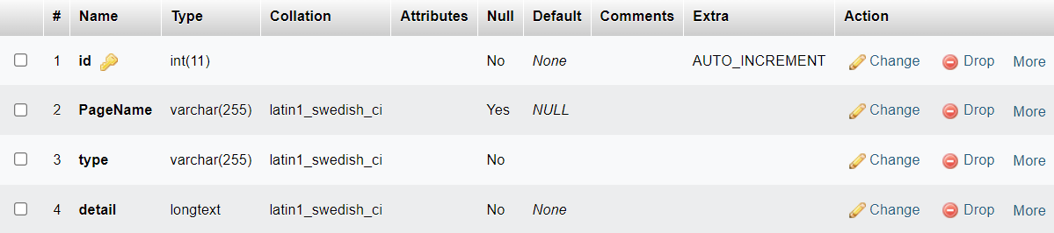

7. Subscriber
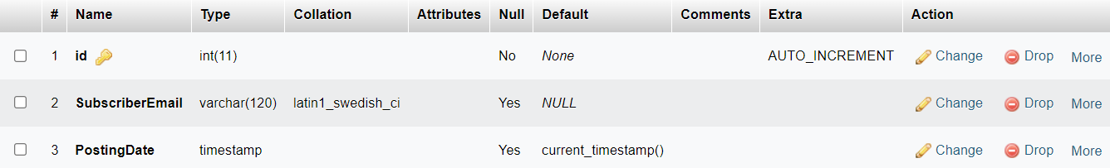

8. Testimonial 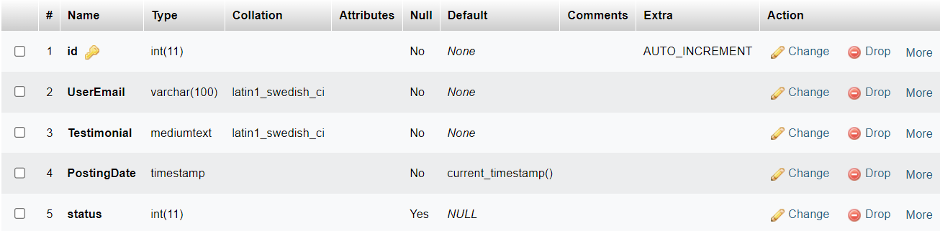

9. Users
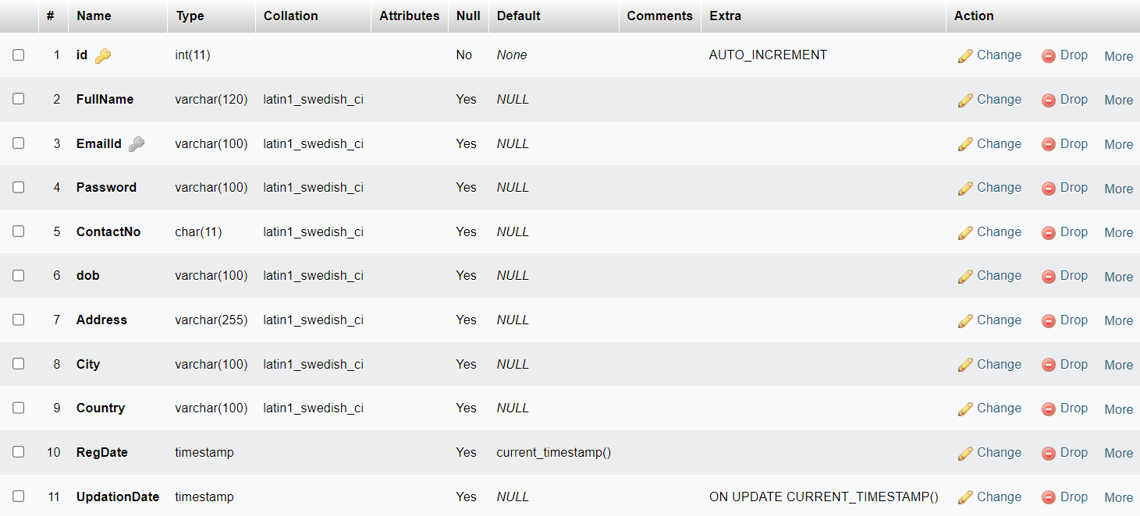
- Vehicles
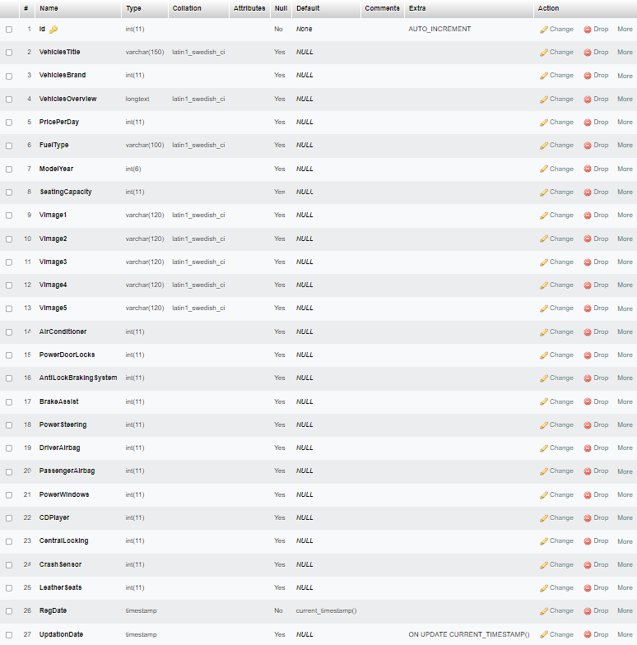
FORM DESIGN
1. Profile Edit Page
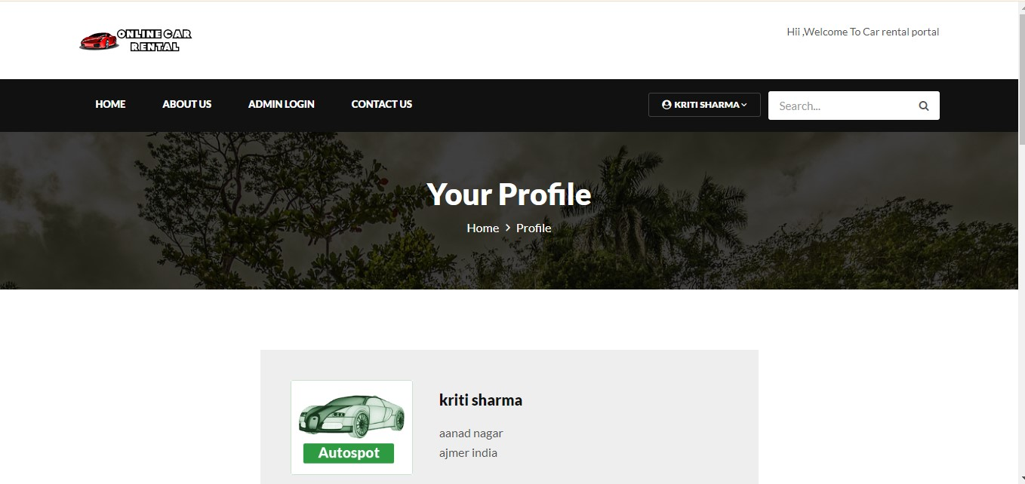
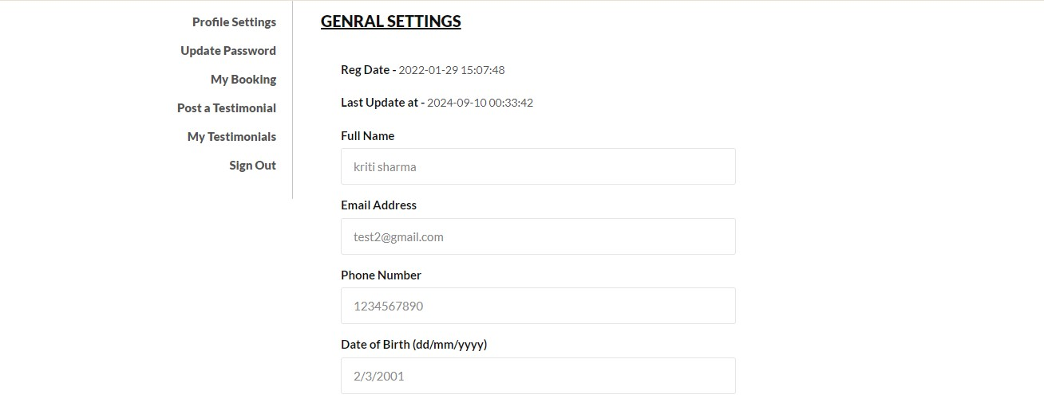
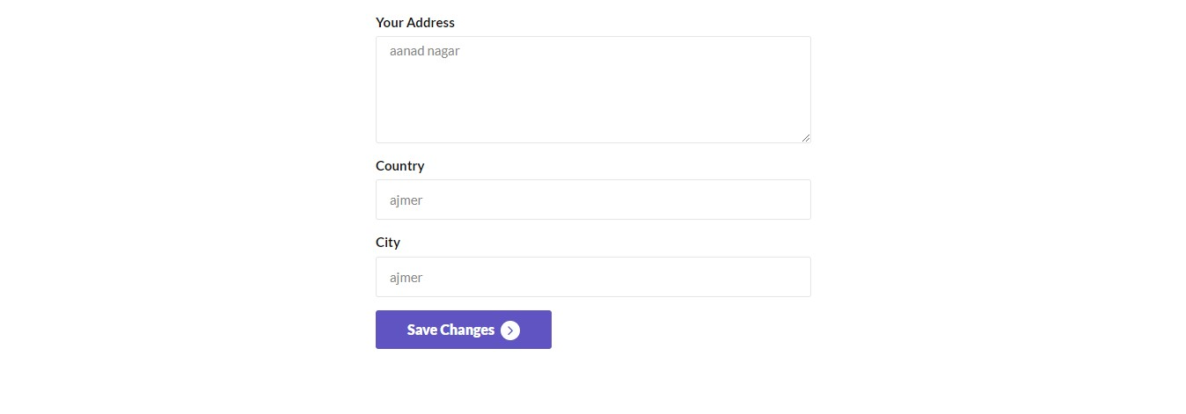
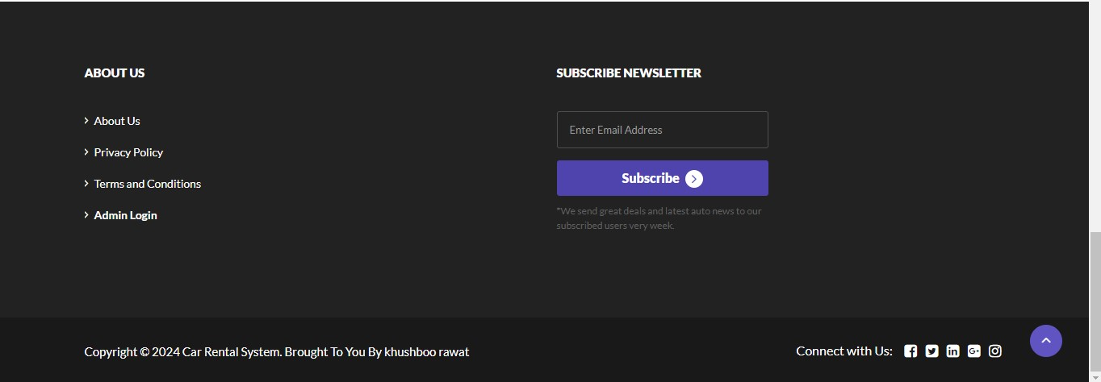

- Update Password Page
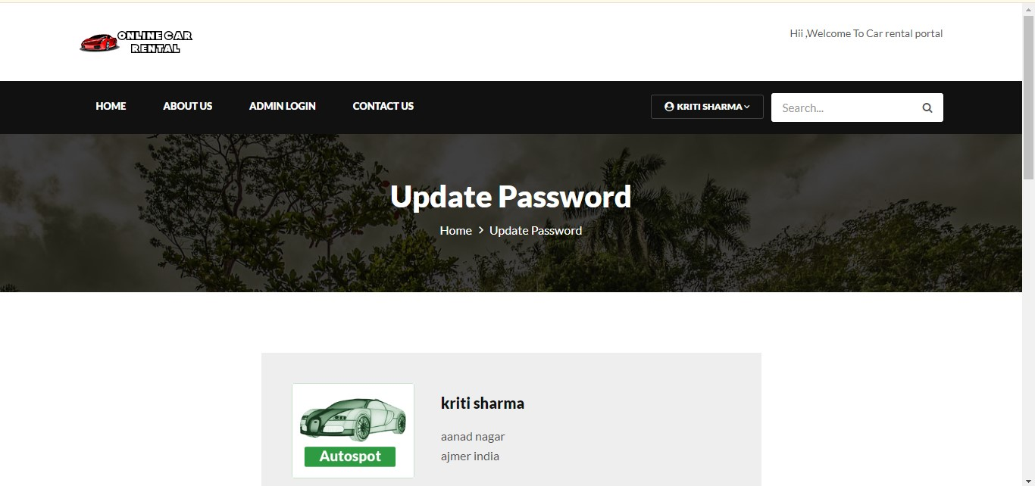
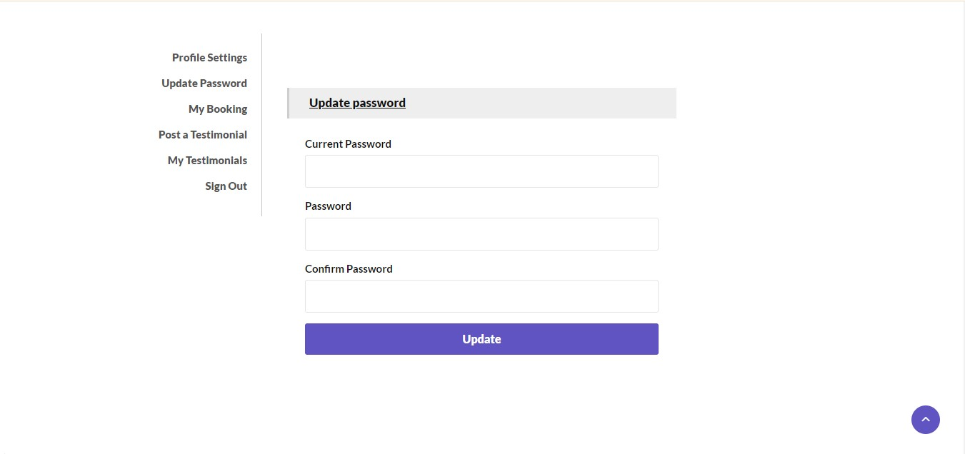

Coding

User Part:

1. Index.php

<?php
session_start();
include('includes/config.php');
error_reporting(0);
?>
<!DOCTYPE HTML>
<html lang="en">
<head>
<meta http-equiv="Content-Type" content="text/html; charset=utf-8">
<meta http-equiv="X-UA-Compatible" content="IE=edge">
<meta name="viewport" content="width=device-width,initial-scale=1">
<meta name="keywords" content="">
<meta name="description" content="">
<title>Car Rental Portal</title>
<!--Bootstrap -->
<link rel="stylesheet" href="assets/css/bootstrap.min.css" type="text/css">
<link rel="stylesheet" href="assets/css/style.css" type="text/css">
<link rel="stylesheet" href="assets/css/owl.carousel.css" type="text/css">
<link rel="stylesheet" href="assets/css/owl.transitions.css" type="text/css">
<link href="assets/css/slick.css" rel="stylesheet">
<link href="assets/css/bootstrap-slider.min.css" rel="stylesheet">
<link href="assets/css/font-awesome.min.css" rel="stylesheet">
<link rel="stylesheet" id="switcher-css" type="text/css" href="assets/switcher/css/switcher.css" media="all" />
<link rel="alternate stylesheet" type="text/css" href="assets/switcher/css/red.css" title="red" media="all" data-default-color="true" />
<link rel="alternate stylesheet" type="text/css" href="assets/switcher/css/orange.css" title="orange" media="all" />
<link rel="alternate stylesheet" type="text/css" href="assets/switcher/css/blue.css" title="blue" media="all" />
<link rel="alternate stylesheet" type="text/css" href="assets/switcher/css/pink.css" title="pink" media="all" />
<link rel="alternate stylesheet" type="text/css" href="assets/switcher/css/green.css" title="green" media="all" />
<link rel="alternate stylesheet" type="text/css" href="assets/switcher/css/purple.css" title="purple" media="all" />
<link rel="apple-touch-icon-precomposed" sizes="144x144" href="assets/images/favicon-icon/apple-touch-icon-144-precomposed.png">
<link rel="apple-touch-icon-precomposed" sizes="114x114" href="assets/images/favicon-icon/apple-touch-icon-114-precomposed.html">
<link rel="apple-touch-icon-precomposed" sizes="72x72" href="assets/images/favicon-icon/apple-touch-icon-72-precomposed.png">
<link rel="apple-touch-icon-precomposed" href="assets/images/favicon-icon/apple-touch-icon-57-precomposed.png">
<link rel="shortcut icon" href="assets/images/favicon-icon/favicon.png">
<link href="https://fonts.googleapis.com/css?family=Lato:300,400,700,900" rel="stylesheet">
</head>
<body>
<!-- Start Switcher -->
<?php include('includes/colorswitcher.php');?>
<!-- /Switcher -->
<!--Header-->
<?php include('includes/header.php');?>
<!-- /Header -->
<!-- Banners -->
<section id="banner" class="banner-section">
<div class="container">
<div class="div_zindex">
<div class="row">
<div class="col-md-5 col-md-push-7">
<div class="banner_content">
<h1>Find the right car for you.</h1>
<p>We have more than a thousand cars for you to choose. </p>
<a href="#" class="btn">Read More <span class="angle_arrow"><i class="fa fa-angle-right" aria-hidden="true"></i></span></a> </div>
</div>
</div>
</div>
</div>
</section>
<!-- /Banners -->
<!-- Resent Cat-->
<section class="section-padding gray-bg">
<div class="container">
<div class="section-header text-center">
<h2>Find the Best <span>CarForYou</span></h2>
<p>There are many variations of passages of Lorem Ipsum available, but the majority have suffered alteration in some form, by injected humour, or randomised words which don't look even slightly believable. If you are going to use a passage of Lorem Ipsum, you need to be sure there isn't anything embarrassing hidden in the middle of text.</p>
</div>
<div class="row">
<!-- Nav tabs -->
<div class="recent-tab">
<ul class="nav nav-tabs" role="tablist">
<li role="presentation" class="active"><a href="#resentnewcar" role="tab" data-toggle="tab">New Car</a></li>
</ul>
</div>
<!-- Recently Listed New Cars -->
<div class="tab-content">
<div role="tabpanel" class="tab-pane active" id="resentnewcar">

<?php $sql = "SELECT tblvehicles.VehiclesTitle,tblbrands.BrandName,tblvehicles.PricePerDay,tblvehicles.FuelType,tblvehicles.ModelYear,tblvehicles.id,tblvehicles.SeatingCapacity,tblvehicles.VehiclesOverview,tblvehicles.Vimage1 from tblvehicles join tblbrands on tblbrands.id=tblvehicles.VehiclesBrand";
$query = $dbh -> prepare($sql);
$query->execute();
$results=$query->fetchAll(PDO::FETCH_OBJ);
$cnt=1;
if($query->rowCount() > 0)
{
foreach($results as $result)
{
?>
<div class="col-list-3">
<div class="recent-car-list">
<div class="car-info-box"> <a href="vehical-details.php?vhid=<?php echo htmlentities($result->id);?>"><img src="admin/img/vehicleimages/<?php echo htmlentities($result->Vimage1);?>" class="img-responsive" alt="image"></a>
<ul>
<li><i class="fa fa-car" aria-hidden="true"></i><?php echo htmlentities($result->FuelType);?></li>
<li><i class="fa fa-calendar" aria-hidden="true"></i><?php echo htmlentities($result->ModelYear);?> Model</li>
<li><i class="fa fa-user" aria-hidden="true"></i><?php echo htmlentities($result->SeatingCapacity);?> seats</li>
</ul>
</div>
<div class="car-title-m">
<h6><a href="vehical-details.php?vhid=<?php echo htmlentities($result->id);?>"><?php echo htmlentities($result->BrandName);?> , <?php echo htmlentities($result->VehiclesTitle);?></a></h6>
<span class="price">$<?php echo htmlentities($result->PricePerDay);?> /Day</span>
</div>
<div class="inventory_info_m">
<p><?php echo substr($result->VehiclesOverview,0,70);?></p>
</div>
</div>
</div>
<?php }}?>
</div>
</div>
</div>
</section>
<!-- /Resent Cat -->
<!-- Fun Facts-->
<section class="fun-facts-section">
<div class="container div_zindex">
<div class="row">
<div class="col-lg-3 col-xs-6 col-sm-3">
<div class="fun-facts-m">
<div class="cell">
<h2><i class="fa fa-calendar" aria-hidden="true"></i>40+</h2>
<p>Years In Business</p>
</div>
</div>
</div>
<div class="col-lg-3 col-xs-6 col-sm-3">
<div class="fun-facts-m">
<div class="cell">
<h2><i class="fa fa-car" aria-hidden="true"></i>1200+</h2>
<p>New Cars For Sale</p>
</div>
</div>
</div>
<div class="col-lg-3 col-xs-6 col-sm-3">
<div class="fun-facts-m">
<div class="cell">
<h2><i class="fa fa-car" aria-hidden="true"></i>1000+</h2>
<p>Used Cars For Sale</p>
</div>
</div>
</div>
<div class="col-lg-3 col-xs-6 col-sm-3">
<div class="fun-facts-m">
<div class="cell">
<h2><i class="fa fa-user-circle-o" aria-hidden="true"></i>600+</h2>
<p>Satisfied Customers</p>
</div>
</div>
</div>
</div>
</div>
<!-- Dark Overlay-->
<div class="dark-overlay"></div>
</section>
<!-- /Fun Facts-->
<!--Testimonial -->
<section class="section-padding testimonial-section parallex-bg">
<div class="container div_zindex">
<div class="section-header white-text text-center">
<h2>Our Satisfied <span>Customers</span></h2>
</div>
<div class="row">
<div id="testimonial-slider">
<?php
$tid=1;
$sql = "SELECT tbltestimonial.Testimonial,tblusers.FullName from tbltestimonial join tblusers on tbltestimonial.UserEmail=tblusers.EmailId where tbltestimonial.status=:tid";
$query = $dbh -> prepare($sql);
$query->bindParam(':tid',$tid, PDO::PARAM_STR);
$query->execute();
$results=$query->fetchAll(PDO::FETCH_OBJ);
$cnt=1;
if($query->rowCount() > 0)
{
foreach($results as $result)
{ ?>
<div class="testimonial-m">
<div class="testimonial-img"> <img src="assets/images/cat-profile.png" alt="" /> </div>
<div class="testimonial-content">
<div class="testimonial-heading">
<h5><?php echo htmlentities($result->FullName);?></h5>
<p><?php echo htmlentities($result->Testimonial);?></p>
</div>
</div>
</div>
<!-- <div class="testimonial-m">
<div class="testimonial-img"> <img src="assets/images/cat.png" alt="" /> </div>
<div class="testimonial-content">
<div class="testimonial-heading">
<h5><?php echo htmlentities($result->FullName);?></h5>
<p><?php echo htmlentities($result->Testimonial);?></p>
</div>
</div>
</div> -->
<?php }} ?>
</div>
</div>
</div>
<!-- Dark Overlay-->
<div class="dark-overlay"></div>
</section>
<!-- /Testimonial-->
<!--Footer -->
<?php include('includes/footer.php');?>
<!-- /Footer-->
<!--Back to top-->
<div id="back-top" class="back-top"> <a href="#top"><i class="fa fa-angle-up" aria-hidden="true"></i> </a> </div>
<!--/Back to top-->
<!--Login-Form -->
<?php include('includes/login.php');?>
<!--/Login-Form -->
<!--Register-Form -->
<?php include('includes/registration.php');?>
<!--/Register-Form -->
<!--Forgot-password-Form -->
<?php include('includes/forgotpassword.php');?>
<!--/Forgot-password-Form -->
<!-- Scripts -->
<script src="assets/js/jquery.min.js"></script>
<script src="assets/js/bootstrap.min.js"></script>
<script src="assets/js/interface.js"></script>
<!--Switcher-->
<script src="assets/switcher/js/switcher.js"></script>
<!--bootstrap-slider-JS-->
<script src="assets/js/bootstrap-slider.min.js"></script>
<!--Slider-JS-->
<script src="assets/js/slick.min.js"></script>
<script src="assets/js/owl.carousel.min.js"></script>
</body>
<!-- Mirrored from themes.webmasterdriver.net/carforyou/demo/index.html by HTTrack Website Copier/3.x [XR&CO'2014], Fri, 16 Jun 2017 07:22:11 GMT -->
</html>

2. Header.php

<header>
<div class="default-header">
<div class="container">
<div class="row">
<div class="col-sm-3 col-md-2">
<div class="logo"> <a href="index.php"><img src="assets/images/logg.png" alt="logo"/></a> </div>
</div>
<div class="col-sm-9 col-md-10">
<div class="header_info">
<div class="header_widgets">
<div class="circle_icon"> <i class="fa fa-envelope" aria-hidden="true"></i> </div>
<p class="uppercase_text">For Support Mail us : </p>
<a href="mailto:info@example.com">info@gmail.com</a> </div>
<div class="header_widgets">
<div class="circle_icon"> <i class="fa fa-phone" aria-hidden="true"></i> </div>
<p class="uppercase_text">Service Helpline Call Us: </p>
<a href="tel:61-1234-5678-09">+91-9876543210</a> </div>
<div class="social-follow">
<ul>
<li><a href="https://facebook.com/"><i class="fa fa-facebook-square" aria-hidden="true"></i></a></li>
<li><a href="https://twitter.com/"><i class="fa fa-twitter-square" aria-hidden="true"></i></a></li>
<li><a href="https://www.linkedin.com/"><i class="fa fa-linkedin-square" aria-hidden="true"></i></a></li>
<li><a href="https://www.google.com/"><i class="fa fa-google-plus-square" aria-hidden="true"></i></a></li>
<li><a href="https://www.instagram.com/"><i class="fa fa-instagram" aria-hidden="true"></i></a></li>
</ul>
</div>
<?php if(strlen($_SESSION['login'])==0){?>
<div class="login_btn"> <a href="#loginform" class="btn btn-xs uppercase" data-toggle="modal" data-dismiss="modal">Login / Register</a> </div>
<?php }
else{
echo " Hii ,Welcome To Car rental portal";
} ?>
</div>
</div>
</div>
</div>
</div>
<!-- Navigation -->
<nav id="navigation_bar" class="navbar navbar-default">
<div class="container">
<div class="navbar-header">
<button id="menu_slide" data-target="#navigation" aria-expanded="false" data-toggle="collapse" class="navbar-toggle collapsed" type="button"> <span class="sr-only">Toggle navigation</span> <span class="icon-bar"></span> <span class="icon-bar"></span> <span class="icon-bar"></span> </button>
</div>
<div class="header_wrap">
<div class="user_login">
<ul>
<li class="dropdown"> <a href="#" data-toggle="dropdown" aria-haspopup="true" aria-expanded="false"><i class="fa fa-user-circle" aria-hidden="true"></i>
<?php
$email=$_SESSION['login'];
$sql ="SELECT FullName FROM tblusers WHERE EmailId=:email ";
$query= $dbh -> prepare($sql);
$query-> bindParam(':email', $email, PDO::PARAM_STR);
$query-> execute();
$results=$query->fetchAll(PDO::FETCH_OBJ);
if($query->rowCount() > 0)
{
foreach($results as $result)
{
echo htmlentities($result->FullName); }}?><i class="fa fa-angle-down" aria-hidden="true"></i></a>
<ul class="dropdown-menu">
<?php if($_SESSION['login']){?>
<li><a href="profile.php">Profile Settings</a></li>
<li><a href="update-password.php">Update Password</a></li>
<li><a href="my-booking.php">My Booking</a></li>
<li><a href="post-testimonial.php">Post a Testimonial</a></li>
<li><a href="my-testimonials.php">My Testimonial</a></li>
<li><a href="logout.php">Sign Out</a></li>
<?php } else { ?>
<li><a href="#loginform" data-toggle="modal" data-dismiss="modal">Profile Settings</a></li>
<li><a href="#loginform" data-toggle="modal" data-dismiss="modal">Update Password</a></li>
<li><a href="#loginform" data-toggle="modal" data-dismiss="modal">My Booking</a></li>
<li><a href="#loginform" data-toggle="modal" data-dismiss="modal">Post a Testimonial</a></li>
<li><a href="#loginform" data-toggle="modal" data-dismiss="modal">My Testimonial</a></li>
<li><a href="#loginform" data-toggle="modal" data-dismiss="modal">Sign Out</a></li>
<?php } ?>
</ul>
</li>
</ul>
</div>
<div class="header_search">
3. Footer.php
<?php
if(isset($_POST['emailsubscibe']))
{
$subscriberemail=$_POST['subscriberemail'];
$sql ="SELECT SubscriberEmail FROM tblsubscribers WHERE SubscriberEmail=:subscriberemail";
$query= $dbh -> prepare($sql);
$query-> bindParam(':subscriberemail', $subscriberemail, PDO::PARAM_STR);
$query-> execute();
$results = $query -> fetchAll(PDO::FETCH_OBJ);
$cnt=1;
if($query -> rowCount() > 0)
{
echo "<script>alert('Already Subscribed.');</script>";
}
else{
$sql="INSERT INTO tblsubscribers(SubscriberEmail) VALUES(:subscriberemail)";
$query = $dbh->prepare($sql);
$query->bindParam(':subscriberemail',$subscriberemail,PDO::PARAM_STR);
$query->execute();
$lastInsertId = $dbh->lastInsertId();
if($lastInsertId)
{
echo "<script>alert('Subscribed successfully.');</script>";
}
else
{
echo "<script>alert('Something went wrong. Please try again');</script>";
}
}
}
?>

<footer>
<div class="footer-top">
<div class="container">
<div class="row">

<div class="col-md-6">
<h6>About Us</h6>
<ul>

<li><a href="page.php?type=aboutus">About Us</a></li>
<li><a href="page.php?type=faqs">FAQs</a></li>
<li><a href="page.php?type=privacy">Privacy Policy</a></li>
<li><a href="page.php?type=terms">Terms and Conditions</a></li>
<!-- <li><a href="admin/"><b>Admin Login</b></a></li> -->
</ul>
</div>

<div class="col-md-3 col-sm-6">
<h6>Subscribe Newsletter</h6>
<div class="newsletter-form">
<form method="post">
<div class="form-group">
<input type="email" name="subscriberemail" class="form-control newsletter-input" required placeholder="Enter Email Address" />
</div>
<button type="submit" name="emailsubscibe" class="btn btn-block">Subscribe <span class="angle_arrow"><i class="fa fa-angle-right" aria-hidden="true"></i></span></button>
</form>
<p class="subscribed-text">*We send great deals and latest auto news to our subscribed users very week.</p></div>
</div>
</div>
</div>
</div>
<div class="footer-bottom">
<div class="container">
<div class="row">
<div class="col-md-6 col-md-push-6 text-right">
<div class="footer_widget">
<p>Connect with Us:</p>
<ul>
<li><a href="https://facebook.com/"><i class="fa fa-facebook-square" aria-hidden="true"></i></a></li>
<li><a href="https://twitter.com/"><i class="fa fa-twitter-square" aria-hidden="true"></i></a></li>
<li><a href="https://www.linkedin.com/"><i class="fa fa-linkedin-square" aria-hidden="true"></i></a></li>
<li><a href="https://www.google.com/"><i class="fa fa-google-plus-square" aria-hidden="true"></i></a></li>
<li><a href="https://www.instagram.com/"><i class="fa fa-instagram" aria-hidden="true"></i></a></li>
</ul>
</div>
</div>
<div class="col-md-6 col-md-pull-6">
<p class="copy-right">Copyright &copy; 2023-24 Car Rental System. Brought To You By <a href="https://github.com/niteesh-bhat/carrental">khushboo rawat </a></p>
</div>
</div>
</div>
</div>
</footer>
4. Login.php
<?php
if(isset($_POST['login']))
{
$email=$_POST['email'];
$password=md5($_POST['password']);
$sql ="SELECT EmailId,Password,FullName FROM tblusers WHERE EmailId=:email and Password=:password";
$query= $dbh -> prepare($sql);
$query-> bindParam(':email', $email, PDO::PARAM_STR);
$query-> bindParam(':password', $password, PDO::PARAM_STR);
$query-> execute();
$results=$query->fetchAll(PDO::FETCH_OBJ);
if($query->rowCount() > 0)
{
$_SESSION['login']=$_POST['email'];
$_SESSION['fname']=$results->FullName;
$currentpage=$_SERVER['REQUEST_URI'];
echo "<script type='text/javascript'> document.location = '$currentpage'; </script>";
} else{

echo "<script>alert('Invalid Details');</script>";

}

}

?>

<div class="modal fade" id="loginform">
<div class="modal-dialog" role="document">
<div class="modal-content">
<div class="modal-header">
<button type="button" class="close" data-dismiss="modal" aria-label="Close"><span aria-hidden="true">&times;</span></button>
<h3 class="modal-title">Login</h3>
</div>
<div class="modal-body">
<div class="row">
<div class="login_wrap">
<div class="col-md-12 col-sm-6">
<form method="post">
<div class="form-group">
<input type="email" class="form-control" name="email" placeholder="Email address*">
</div>
<div class="form-group">
<input type="password" class="form-control" name="password" placeholder="Password*">
</div>
<div class="form-group checkbox">
<input type="checkbox" id="remember">

</div>
<div class="form-group">
<input type="submit" name="login" value="Login" class="btn btn-block">
</div>
</form>
</div>

</div>
</div>
</div>
<div class="modal-footer text-center">
<p>Don't have an account? <a href="#signupform" data-toggle="modal" data-dismiss="modal">Signup Here</a></p>
<p><a href="#forgotpassword" data-toggle="modal" data-dismiss="modal">Forgot Password ?</a></p>
</div>
</div>
</div>
</div>
5. Registration.php
<?php
//error_reporting(0);
if(isset($_POST['signup']))
{
$fname=$_POST['fullname'];
$email=$_POST['emailid'];
$mobile=$_POST['mobileno'];
$password=md5($_POST['password']);
$sql="INSERT INTO tblusers(FullName,EmailId,ContactNo,Password) VALUES(:fname,:email,:mobile,:password)";
$query = $dbh->prepare($sql);
$query->bindParam(':fname',$fname,PDO::PARAM_STR);
$query->bindParam(':email',$email,PDO::PARAM_STR);
$query->bindParam(':mobile',$mobile,PDO::PARAM_STR);
$query->bindParam(':password',$password,PDO::PARAM_STR);
$query->execute();
$lastInsertId = $dbh->lastInsertId();
if($lastInsertId)
{
echo "<script>alert('Registration successfull. Now you can login');</script>";
}
else
{
echo "<script>alert('Something went wrong. Please try again');</script>";
}
}

?>

<script>
function checkAvailability() {
$("#loaderIcon").show();
jQuery.ajax({
url: "check_availability.php",
data:'emailid='+$("#emailid").val(),
type: "POST",
success:function(data){
$("#user-availability-status").html(data);
$("#loaderIcon").hide();
},
error:function (){}
});
}
</script>
<script type="text/javascript">
function valid()
{
if(document.signup.password.value!= document.signup.confirmpassword.value)
{
alert("Password and Confirm Password Field do not match !!");
document.signup.confirmpassword.focus();
return false;
}
return true;
}
</script>
<div class="modal fade" id="signupform">
<div class="modal-dialog" role="document">
<div class="modal-content">
<div class="modal-header">
<button type="button" class="close" data-dismiss="modal" aria-label="Close"><span aria-hidden="true">&times;</span></button>
<h3 class="modal-title">Sign Up</h3>
</div>
<div class="modal-body">
<div class="row">
<div class="signup_wrap">
<div class="col-md-12 col-sm-6">
<form method="post" name="signup" onSubmit="return valid();">
<div class="form-group">
<input type="text" class="form-control" name="fullname" placeholder="Full Name" required="required">
</div>
<div class="form-group">
<input type="text" class="form-control" name="mobileno" placeholder="Mobile Number" maxlength="10" required="required">
</div>
<div class="form-group">
<input type="email" class="form-control" name="emailid" id="emailid" onBlur="checkAvailability()" placeholder="Email Address" required="required">
<span id="user-availability-status" style="font-size:12px;"></span>
</div>
<div class="form-group">
<input type="password" class="form-control" name="password" placeholder="Password" required="required">
</div>
<div class="form-group">
<input type="password" class="form-control" name="confirmpassword" placeholder="Confirm Password" required="required">
</div>
<div class="form-group checkbox">
<input type="checkbox" id="terms_agree" required="required" checked="">
<label for="terms_agree">I Agree with <a href="#">Terms and Conditions</a></label>
</div>
<div class="form-group">
<input type="submit" value="Sign Up" name="signup" id="submit" class="btn btn-block">
</div>
</form>
</div>

</div>
</div>
</div>
<div class="modal-footer text-center">
<p>Already got an account? <a href="#loginform" data-toggle="modal" data-dismiss="modal">Login Here</a></p>
</div>
</div>
</div>
</div>
6. ForgetPassword.php
<?php
if(isset($_POST['update']))
{
$email=$_POST['email'];
$mobile=$_POST['mobile'];
$newpassword=md5($_POST['newpassword']);
$sql ="SELECT EmailId FROM tblusers WHERE EmailId=:email and ContactNo=:mobile";
$query= $dbh -> prepare($sql);
$query-> bindParam(':email', $email, PDO::PARAM_STR);
$query-> bindParam(':mobile', $mobile, PDO::PARAM_STR);
$query-> execute();
$results = $query -> fetchAll(PDO::FETCH_OBJ);
if($query -> rowCount() > 0)
{
$con="update tblusers set Password=:newpassword where EmailId=:email and ContactNo=:mobile";
$chngpwd1 = $dbh->prepare($con);
$chngpwd1-> bindParam(':email', $email, PDO::PARAM_STR);
$chngpwd1-> bindParam(':mobile', $mobile, PDO::PARAM_STR);
$chngpwd1-> bindParam(':newpassword', $newpassword, PDO::PARAM_STR);
$chngpwd1->execute();
echo "<script>alert('Your Password succesfully changed');</script>";
}
else {
echo "<script>alert('Email id or Mobile no is invalid');</script>";
}
}

?>
<script type="text/javascript">
function valid()
{
if(document.chngpwd.newpassword.value!= document.chngpwd.confirmpassword.value)
{
alert("New Password and Confirm Password Field do not match !!");
document.chngpwd.confirmpassword.focus();
return false;
}
return true;
}
</script>
<div class="modal fade" id="forgotpassword">
<div class="modal-dialog" role="document">
<div class="modal-content">
<div class="modal-header">

<button type="button" class="close" data-dismiss="modal" aria-label="Close"><span aria-hidden="true">&times;</span></button>
<h3 class="modal-title">Password Recovery</h3>
</div>
<div class="modal-body">
<div class="row">
<div class="forgotpassword_wrap">
<div class="col-md-12">
<form name="chngpwd" method="post" onSubmit="return valid();">
<div class="form-group">
<input type="email" name="email" class="form-control" placeholder="Your Email address*" required="">
</div>
<div class="form-group">
<input type="text" name="mobile" class="form-control" placeholder="Your Reg. Mobile*" required="">
</div>
<div class="form-group">
<input type="password" name="newpassword" class="form-control" placeholder="New Password*" required="">
</div>
<div class="form-group">
<input type="password" name="confirmpassword" class="form-control" placeholder="Confirm Password*" required="">
</div>
<div class="form-group">
<input type="submit" value="Reset My Password" name="update" class="btn btn-block">
</div>
</form>
<div class="text-center">
<p class="gray_text">For security reasons we don't store your password. Your password will be reset and a new one will be send.</p>
<p><a href="#loginform" data-toggle="modal" data-dismiss="modal"><i class="fa fa-angle-double-left" aria-hidden="true"></i> Back to Login</a></p>
</div>
</div>
</div>
</div>
</div>
</div>
</div>
</div>
7. CarListing.php
<?php
session_start();
include('includes/config.php');
error_reporting(0);
?>

<!DOCTYPE HTML>
<html lang="en">
<head>
<meta http-equiv="Content-Type" content="text/html; charset=utf-8">
<meta http-equiv="X-UA-Compatible" content="IE=edge">
<meta name="viewport" content="width=device-width,initial-scale=1">
<meta name="keywords" content="">
<meta name="description" content="">
<title>Car Rental Portal | Car Listing</title>
<!--Bootstrap -->
<link rel="stylesheet" href="assets/css/bootstrap.min.css" type="text/css">
<!--Custome Style -->
<link rel="stylesheet" href="assets/css/style.css" type="text/css">
<!--OWL Carousel slider-->
<link rel="stylesheet" href="assets/css/owl.carousel.css" type="text/css">
<link rel="stylesheet" href="assets/css/owl.transitions.css" type="text/css">
<!--slick-slider -->
<link href="assets/css/slick.css" rel="stylesheet">
<!--bootstrap-slider -->
<link href="assets/css/bootstrap-slider.min.css" rel="stylesheet">
<!--FontAwesome Font Style -->
<link href="assets/css/font-awesome.min.css" rel="stylesheet">

<!-- SWITCHER -->
<link rel="stylesheet" id="switcher-css" type="text/css" href="assets/switcher/css/switcher.css" media="all" />
<link rel="alternate stylesheet" type="text/css" href="assets/switcher/css/red.css" title="red" media="all" data-default-color="true" />
<link rel="alternate stylesheet" type="text/css" href="assets/switcher/css/orange.css" title="orange" media="all" />
<link rel="alternate stylesheet" type="text/css" href="assets/switcher/css/blue.css" title="blue" media="all" />
<link rel="alternate stylesheet" type="text/css" href="assets/switcher/css/pink.css" title="pink" media="all" />
<link rel="alternate stylesheet" type="text/css" href="assets/switcher/css/green.css" title="green" media="all" />
<link rel="alternate stylesheet" type="text/css" href="assets/switcher/css/purple.css" title="purple" media="all" />

<!-- Fav and touch icons -->
<link rel="apple-touch-icon-precomposed" sizes="144x144" href="assets/images/favicon-icon/apple-touch-icon-144-precomposed.png">
<link rel="apple-touch-icon-precomposed" sizes="114x114" href="assets/images/favicon-icon/apple-touch-icon-114-precomposed.html">
<link rel="apple-touch-icon-precomposed" sizes="72x72" href="assets/images/favicon-icon/apple-touch-icon-72-precomposed.png">
<link rel="apple-touch-icon-precomposed" href="assets/images/favicon-icon/apple-touch-icon-57-precomposed.png">
<link rel="shortcut icon" href="assets/images/favicon-icon/favicon.png">
<link href="https://fonts.googleapis.com/css?family=Lato:300,400,700,900" rel="stylesheet">
</head>
<body>

<!-- Start Switcher -->
<?php include('includes/colorswitcher.php');?>
<!-- /Switcher -->

<!--Header-->
<?php include('includes/header.php');?>
<!-- /Header -->

<!--Page Header-->
<section class="page-header listing_page">
<div class="container">
<div class="page-header_wrap">
<div class="page-heading">
<h1>Car Listing</h1>
</div>
<ul class="coustom-breadcrumb">
<li><a href="#">Home</a></li>
<li>Car Listing</li>
</ul>
</div>
</div>
<!-- Dark Overlay-->
<div class="dark-overlay"></div>
</section>
<!-- /Page Header-->

<!--Listing-->
<section class="listing-page">
<div class="container">
<div class="row">
<div class="col-md-9 col-md-push-3">
<div class="result-sorting-wrapper">
<div class="sorting-count">
<?php
//Query for Listing count
$sql = "SELECT id from tblvehicles";
$query = $dbh -> prepare($sql);
$query->bindParam(':vhid',$vhid, PDO::PARAM_STR);
$query->execute();
$results=$query->fetchAll(PDO::FETCH_OBJ);
$cnt=$query->rowCount();
?>
<p><span><?php echo htmlentities($cnt);?> Listings</span></p>
</div>
</div>

<?php $sql = "SELECT tblvehicles.*,tblbrands.BrandName,tblbrands.id as bid from tblvehicles join tblbrands on tblbrands.id=tblvehicles.VehiclesBrand";
$query = $dbh -> prepare($sql);
$query->execute();
$results=$query->fetchAll(PDO::FETCH_OBJ);
$cnt=1;
if($query->rowCount() > 0)
{
foreach($results as $result)
{ ?>
<div class="product-listing-m gray-bg">
<div class="product-listing-img"><img src="admin/img/vehicleimages/<?php echo htmlentities($result->Vimage1);?>" class="img-responsive" alt="Image" /> </a>
</div>
<div class="product-listing-content">
<h5><a href="vehical-details.php?vhid=<?php echo htmlentities($result->id);?>"><?php echo htmlentities($result->BrandName);?> , <?php echo htmlentities($result->VehiclesTitle);?></a></h5>
<p class="list-price">$<?php echo htmlentities($result->PricePerDay);?> Per Day</p>
<ul>
<li><i class="fa fa-user" aria-hidden="true"></i><?php echo htmlentities($result->SeatingCapacity);?> seats</li>
<li><i class="fa fa-calendar" aria-hidden="true"></i><?php echo htmlentities($result->ModelYear);?> model</li>
<li><i class="fa fa-car" aria-hidden="true"></i><?php echo htmlentities($result->FuelType);?></li>
</ul>
<a href="vehical-details.php?vhid=<?php echo htmlentities($result->id);?>" class="btn">View Details <span class="angle_arrow"><i class="fa fa-angle-right" aria-hidden="true"></i></span></a>
</div>
</div>
<?php }} ?>
</div>

<!--Side-Bar-->
<aside class="col-md-3 col-md-pull-9">
<div class="sidebar_widget">
<div class="widget_heading">
<h5><i class="fa fa-filter" aria-hidden="true"></i> Find Your Car </h5>
</div>
<div class="sidebar_filter">
<form action="search-carresult.php" method="post">
<div class="form-group select">
<select class="form-control" name="brand">
<option>Select Brand</option>

<?php $sql = "SELECT * from tblbrands ";
$query = $dbh -> prepare($sql);
$query->execute();
$results=$query->fetchAll(PDO::FETCH_OBJ);
$cnt=1;
if($query->rowCount() > 0)
{
foreach($results as $result)
{ ?>
<option value="<?php echo htmlentities($result->id);?>"><?php echo htmlentities($result->BrandName);?></option>
<?php }} ?>

</select>
</div>
<div class="form-group select">
<select class="form-control" name="fueltype">
<option>Select Fuel Type</option>
<option value="Petrol">Petrol</option>
<option value="Diesel">Diesel</option>
<option value="CNG">CNG</option>
</select>
</div>

<div class="form-group">
<button type="submit" class="btn btn-block"><i class="fa fa-search" aria-hidden="true"></i> Search Car</button>
</div>
</form>
</div>
</div>

<div class="sidebar_widget">
<div class="widget_heading">
<h5><i class="fa fa-car" aria-hidden="true"></i> Recently Listed Cars</h5>
</div>
<div class="recent_addedcars">
<ul>
<?php $sql = "SELECT tblvehicles.*,tblbrands.BrandName,tblbrands.id as bid from tblvehicles join tblbrands on tblbrands.id=tblvehicles.VehiclesBrand order by id desc limit 4";
$query = $dbh -> prepare($sql);
$query->execute();
$results=$query->fetchAll(PDO::FETCH_OBJ);
$cnt=1;
if($query->rowCount() > 0)
{
foreach($results as $result)
{ ?>

<li class="gray-bg">
<div class="recent_post_img"> <a href="vehical-details.php?vhid=<?php echo htmlentities($result->id);?>"><img src="admin/img/vehicleimages/<?php echo htmlentities($result->Vimage1);?>" alt="image"></a> </div>
<div class="recent_post_title"> <a href="vehical-details.php?vhid=<?php echo htmlentities($result->id);?>"><?php echo htmlentities($result->BrandName);?> , <?php echo htmlentities($result->VehiclesTitle);?></a>
<p class="widget_price">$<?php echo htmlentities($result->PricePerDay);?> Per Day</p>
</div>
</li>
<?php }} ?>

</ul>
</div>
</div>
</aside>
<!--/Side-Bar-->
</div>
</div>
</section>
<!-- /Listing-->

<!--Footer -->
<?php include('includes/footer.php');?>
<!-- /Footer-->

<!--Back to top-->
<div id="back-top" class="back-top"> <a href="#top"><i class="fa fa-angle-up" aria-hidden="true"></i> </a> </div>
<!--/Back to top-->

<!--Login-Form -->
<?php include('includes/login.php');?>
<!--/Login-Form -->

<!--Register-Form -->
<?php include('includes/registration.php');?>

<!--/Register-Form -->

<!--Forgot-password-Form -->
<?php include('includes/forgotpassword.php');?>

<!-- Scripts -->
<script src="assets/js/jquery.min.js"></script>
<script src="assets/js/bootstrap.min.js"></script>
<script src="assets/js/interface.js"></script>
<!--Switcher-->
<script src="assets/switcher/js/switcher.js"></script>
<!--bootstrap-slider-JS-->
<script src="assets/js/bootstrap-slider.min.js"></script>
<!--Slider-JS-->
<script src="assets/js/slick.min.js"></script>
<script src="assets/js/owl.carousel.min.js"></script>

</body>
</html>

8. Vehicle_details.php
<?php
session_start();
include('includes/config.php');
error_reporting(0);
if(isset($_POST['submit']))
{
$fromdate=$_POST['fromdate'];
$todate=$_POST['todate'];
$message=$_POST['message'];
$useremail=$_SESSION['login'];
$status=0;
$vhid=$_GET['vhid'];
$sql="INSERT INTO tblbooking(userEmail,VehicleId,FromDate,ToDate,message,Status) VALUES(:useremail,:vhid,:fromdate,:todate,:message,:status)";
$query = $dbh->prepare($sql);
$query->bindParam(':useremail',$useremail,PDO::PARAM_STR);
$query->bindParam(':vhid',$vhid,PDO::PARAM_STR);
$query->bindParam(':fromdate',$fromdate,PDO::PARAM_STR);
$query->bindParam(':todate',$todate,PDO::PARAM_STR);
$query->bindParam(':message',$message,PDO::PARAM_STR);
$query->bindParam(':status',$status,PDO::PARAM_STR);
$query->execute();
$lastInsertId = $dbh->lastInsertId();
if($lastInsertId)
{
echo "<script>alert('Booking successfull.');</script>";
}
else
{
echo "<script>alert('Something went wrong. Please try again');</script>";
}

}

?>

<!DOCTYPE HTML>
<html lang="en">
<head>
<meta http-equiv="Content-Type" content="text/html; charset=utf-8">
<meta http-equiv="X-UA-Compatible" content="IE=edge">
<meta name="viewport" content="width=device-width,initial-scale=1">
<meta name="keywords" content="">
<meta name="description" content="">
<title>Car Rental Port | Vehicle Details</title>
<!--Bootstrap -->
<link rel="stylesheet" href="assets/css/bootstrap.min.css" type="text/css">
<!--Custome Style -->
<link rel="stylesheet" href="assets/css/style.css" type="text/css">
<!--OWL Carousel slider-->
<link rel="stylesheet" href="assets/css/owl.carousel.css" type="text/css">
<link rel="stylesheet" href="assets/css/owl.transitions.css" type="text/css">
<!--slick-slider -->
<link href="assets/css/slick.css" rel="stylesheet">
<!--bootstrap-slider -->
<link href="assets/css/bootstrap-slider.min.css" rel="stylesheet">
<!--FontAwesome Font Style -->
<link href="assets/css/font-awesome.min.css" rel="stylesheet">

<!-- SWITCHER -->
<link rel="stylesheet" id="switcher-css" type="text/css" href="assets/switcher/css/switcher.css" media="all" />
<link rel="alternate stylesheet" type="text/css" href="assets/switcher/css/red.css" title="red" media="all" data-default-color="true" />
<link rel="alternate stylesheet" type="text/css" href="assets/switcher/css/orange.css" title="orange" media="all" />
<link rel="alternate stylesheet" type="text/css" href="assets/switcher/css/blue.css" title="blue" media="all" />
<link rel="alternate stylesheet" type="text/css" href="assets/switcher/css/pink.css" title="pink" media="all" />
<link rel="alternate stylesheet" type="text/css" href="assets/switcher/css/green.css" title="green" media="all" />
<link rel="alternate stylesheet" type="text/css" href="assets/switcher/css/purple.css" title="purple" media="all" />
<link rel="apple-touch-icon-precomposed" sizes="144x144" href="assets/images/favicon-icon/apple-touch-icon-144-precomposed.png">
<link rel="apple-touch-icon-precomposed" sizes="114x114" href="assets/images/favicon-icon/apple-touch-icon-114-precomposed.html">
<link rel="apple-touch-icon-precomposed" sizes="72x72" href="assets/images/favicon-icon/apple-touch-icon-72-precomposed.png">
<link rel="apple-touch-icon-precomposed" href="assets/images/favicon-icon/apple-touch-icon-57-precomposed.png">
<link rel="shortcut icon" href="assets/images/favicon-icon/favicon.png">
<link href="https://fonts.googleapis.com/css?family=Lato:300,400,700,900" rel="stylesheet">
</head>
<body>

<!-- Start Switcher -->
<?php include('includes/colorswitcher.php');?>
<!-- /Switcher -->

<!--Header-->
<?php include('includes/header.php');?>
<!-- /Header -->

<!--Listing-Image-Slider-->

<?php
$vhid=intval($_GET['vhid']);
$sql = "SELECT tblvehicles.*,tblbrands.BrandName,tblbrands.id as bid from tblvehicles join tblbrands on tblbrands.id=tblvehicles.VehiclesBrand where tblvehicles.id=:vhid";
$query = $dbh -> prepare($sql);
$query->bindParam(':vhid',$vhid, PDO::PARAM_STR);
$query->execute();
$results=$query->fetchAll(PDO::FETCH_OBJ);
$cnt=1;
if($query->rowCount() > 0)
{
foreach($results as $result)
{
$_SESSION['brndid']=$result->bid;
?>

<section id="listing_img_slider">
<div><img src="admin/img/vehicleimages/image3.jpg" class="img-responsive" alt="image" width="900" height="560"></div><!-- in src<?php echo htmlentities($result->Vimage1);?> -->
<div><img src="admin/img/vehicleimages/image2.jpg" class="img-responsive" alt="image" width="900" height="560"></div>
<div><img src="admin/img/vehicleimages/image5.jpg" class="img-responsive" alt="image" width="900" height="560"></div>
<div><img src="admin/img/vehicleimages/image4.jpg" class="img-responsive" alt="image" width="900" height="560"></div>
<?php if($result->Vimage5=="")
{

} else {
?>
<div><img src="admin/img/vehicleimages/image1.jpg" class="img-responsive" alt="image" width="900" height="560"></div>
<?php } ?>
</section>
<!--/Listing-Image-Slider-->

<!--Listing-detail-->
<section class="listing-detail">
<div class="container">
<div class="listing_detail_head row">
<div class="col-md-9">
<h2><?php echo htmlentities($result->BrandName);?> , <?php echo htmlentities($result->VehiclesTitle);?></h2>
</div>
<div class="col-md-3">
<div class="price_info">
<p>$<?php echo htmlentities($result->PricePerDay);?> </p>Per Day

</div>
</div>
</div>
<div class="row">
<div class="col-md-9">
<div class="main_features">
<ul>

<li> <i class="fa fa-calendar" aria-hidden="true"></i>
<h5><?php echo htmlentities($result->ModelYear);?></h5>
<p>Reg.Year</p>
</li>
<li> <i class="fa fa-cogs" aria-hidden="true"></i>
<h5><?php echo htmlentities($result->FuelType);?></h5>
<p>Fuel Type</p>
</li>

<li> <i class="fa fa-user-plus" aria-hidden="true"></i>
<h5><?php echo htmlentities($result->SeatingCapacity);?></h5>
<p>Seats</p>
</li>
</ul>
</div>
<div class="listing_more_info">
<div class="listing_detail_wrap">
<!-- Nav tabs -->
<ul class="nav nav-tabs gray-bg" role="tablist">
<li role="presentation" class="active"><a href="#vehicle-overview " aria-controls="vehicle-overview" role="tab" data-toggle="tab">Vehicle Overview </a></li>

<li role="presentation"><a href="#accessories" aria-controls="accessories" role="tab" data-toggle="tab">Accessories</a></li>
</ul>

<!-- Tab panes -->
<div class="tab-content">
<!-- vehicle-overview -->
<div role="tabpanel" class="tab-pane active" id="vehicle-overview">

<p><?php echo htmlentities($result->VehiclesOverview);?></p>
</div>

<!-- Accessories -->
<div role="tabpanel" class="tab-pane" id="accessories">
<!--Accessories-->
<table>
<thead>
<tr>
<th colspan="2">Accessories</th>
</tr>
</thead>
<tbody>
<tr>
<td>Air Conditioner</td>
<?php if($result->AirConditioner==1)
{
?>
<td><i class="fa fa-check" aria-hidden="true"></i></td>
<?php } else { ?>
<td><i class="fa fa-close" aria-hidden="true"></i></td>
<?php } ?> </tr>

<tr>
<td>AntiLock Braking System</td>
<?php if($result->AntiLockBrakingSystem==1)
{
?>
<td><i class="fa fa-check" aria-hidden="true"></i></td>
<?php } else {?>
<td><i class="fa fa-close" aria-hidden="true"></i></td>
<?php } ?>
</tr>

<tr>
<td>Power Steering</td>
<?php if($result->PowerSteering==1)
{
?>
<td><i class="fa fa-check" aria-hidden="true"></i></td>
<?php } else { ?>
<td><i class="fa fa-close" aria-hidden="true"></i></td>
<?php } ?>
</tr>
<tr>

<td>Power Windows</td>

<?php if($result->PowerWindows==1)
{
?>
<td><i class="fa fa-check" aria-hidden="true"></i></td>
<?php } else { ?>
<td><i class="fa fa-close" aria-hidden="true"></i></td>
<?php } ?>
</tr>

<tr>
<td>CD Player</td>
<?php if($result->CDPlayer==1)
{
?>
<td><i class="fa fa-check" aria-hidden="true"></i></td>
<?php } else { ?>
<td><i class="fa fa-close" aria-hidden="true"></i></td>
<?php } ?>
</tr>

<tr>
<td>Leather Seats</td>
<?php if($result->LeatherSeats==1)
{
?>
<td><i class="fa fa-check" aria-hidden="true"></i></td>
<?php } else { ?>
<td><i class="fa fa-close" aria-hidden="true"></i></td>
<?php } ?>
</tr>

<tr>
<td>Central Locking</td>
<?php if($result->CentralLocking==1)
{
?>
<td><i class="fa fa-check" aria-hidden="true"></i></td>
<?php } else { ?>
<td><i class="fa fa-close" aria-hidden="true"></i></td>
<?php } ?>
</tr>

<tr>
<td>Power Door Locks</td>
<?php if($result->PowerDoorLocks==1)
{
?>
<td><i class="fa fa-check" aria-hidden="true"></i></td>
<?php } else { ?>
<td><i class="fa fa-close" aria-hidden="true"></i></td>
<?php } ?>
</tr>
<tr>
<td>Brake Assist</td>
<?php if($result->BrakeAssist==1)
{
?>
<td><i class="fa fa-check" aria-hidden="true"></i></td>
<?php } else { ?>
<td><i class="fa fa-close" aria-hidden="true"></i></td>
<?php } ?>
</tr>

<tr>
<td>Driver Airbag</td>
<?php if($result->DriverAirbag==1)
{
?>
<td><i class="fa fa-check" aria-hidden="true"></i></td>
<?php } else { ?>
<td><i class="fa fa-close" aria-hidden="true"></i></td>
<?php } ?>
</tr>

<tr>
<td>Passenger Airbag</td>
<?php if($result->PassengerAirbag==1)
{
?>
<td><i class="fa fa-check" aria-hidden="true"></i></td>
<?php } else {?>
<td><i class="fa fa-close" aria-hidden="true"></i></td>
<?php } ?>
</tr>

<tr>
<td>Crash Sensor</td>
<?php if($result->CrashSensor==1)
{
?>
<td><i class="fa fa-check" aria-hidden="true"></i></td>
<?php } else { ?>
<td><i class="fa fa-close" aria-hidden="true"></i></td>
<?php } ?>
</tr>

</tbody>
</table>
</div>
</div>
</div>

</div>
<?php }} ?>

</div>

<!--Side-Bar-->
<aside class="col-md-3">

<div class="share_vehicle">
<p>Share: <a href="#"><i class="fa fa-facebook-square" aria-hidden="true"></i></a> <a href="#"><i class="fa fa-twitter-square" aria-hidden="true"></i></a> <a href="#"><i class="fa fa-linkedin-square" aria-hidden="true"></i></a> <a href="#"><i class="fa fa-google-plus-square" aria-hidden="true"></i></a> </p>
</div>
<div class="sidebar_widget">
<div class="widget_heading">
<h5><i class="fa fa-envelope" aria-hidden="true"></i>Book Now</h5>
</div>
<form method="post">
<div class="form-group">
<input type="text" class="form-control" name="fromdate" placeholder="From Date(dd/mm/yyyy)" required>
</div>
<div class="form-group">
<input type="text" class="form-control" name="todate" placeholder="To Date(dd/mm/yyyy)" required>
</div>
<div class="form-group">
<textarea rows="4" class="form-control" name="message" placeholder="Message" required></textarea>
</div>
<?php if($_SESSION['login'])
{?>
<div class="form-group">
<input type="submit" class="btn" name="submit" value="Book Now">
</div>
<?php } else { ?>
<a href="#loginform" class="btn btn-xs uppercase" data-toggle="modal" data-dismiss="modal">Login For Book</a>

<?php } ?>
</form>
</div>
</aside>
<!--/Side-Bar-->
</div>

<div class="space-20"></div>
<div class="divider"></div>

<!--Similar-Cars-->
<div class="similar_cars">
<h3>Similar Cars</h3>
<div class="row">
<?php
$bid=$_SESSION['brndid'];
$sql="SELECT tblvehicles.VehiclesTitle,tblbrands.BrandName,tblvehicles.PricePerDay,tblvehicles.FuelType,tblvehicles.ModelYear,tblvehicles.id,tblvehicles.SeatingCapacity,tblvehicles.VehiclesOverview,tblvehicles.Vimage1 from tblvehicles join tblbrands on tblbrands.id=tblvehicles.VehiclesBrand where tblvehicles.VehiclesBrand=:bid";
$query = $dbh -> prepare($sql);
$query->bindParam(':bid',$bid, PDO::PARAM_STR);
$query->execute();
$results=$query->fetchAll(PDO::FETCH_OBJ);
$cnt=1;
if($query->rowCount() > 0)
{
foreach($results as $result)
{ ?>
<div class="col-md-3 grid_listing">
<div class="product-listing-m gray-bg">
<div class="product-listing-img"> <a href="vehical-details.php?vhid=<?php echo htmlentities($result->id);?>"><img src="admin/img/vehicleimages/image1.jpg" class="img-responsive" alt="image" /> </a>
</div>
<div class="product-listing-content">
<h5><a href="vehical-details.php?vhid=<?php echo htmlentities($result->id);?>"><?php echo htmlentities($result->BrandName);?> , <?php echo htmlentities($result->VehiclesTitle);?></a></h5>
<p class="list-price">$<?php echo htmlentities($result->PricePerDay);?></p>

<ul class="features_list">

<li><i class="fa fa-user" aria-hidden="true"></i><?php echo htmlentities($result->SeatingCapacity);?> seats</li>
<li><i class="fa fa-calendar" aria-hidden="true"></i><?php echo htmlentities($result->ModelYear);?> model</li>
<li><i class="fa fa-car" aria-hidden="true"></i><?php echo htmlentities($result->FuelType);?></li>
</ul>
</div>
</div>
</div>
<?php }} ?>

</div>
</div>
<!--/Similar-Cars-->

</div>
</section>
<!--/Listing-detail-->

<!--Footer -->
<?php include('includes/footer.php');?>
<!-- /Footer-->

<!--Back to top-->
<div id="back-top" class="back-top"> <a href="#top"><i class="fa fa-angle-up" aria-hidden="true"></i> </a> </div>
<!--/Back to top-->

<!--Login-Form -->
<?php include('includes/login.php');?>
<!--/Login-Form -->

<!--Register-Form -->
<?php include('includes/registration.php');?>

<!--/Register-Form -->

<!--Forgot-password-Form -->
<?php include('includes/forgotpassword.php');?>

<script src="assets/js/jquery.min.js"></script>
<script src="assets/js/bootstrap.min.js"></script>
<script src="assets/js/interface.js"></script>
<script src="assets/switcher/js/switcher.js"></script>
<script src="assets/js/bootstrap-slider.min.js"></script>
<script src="assets/js/slick.min.js"></script>
<script src="assets/js/owl.carousel.min.js"></script>

</body>
</html>

9. Searchcarresult.php

<?php
session_start();
include('includes/config.php');
error_reporting(0);
?>

<!DOCTYPE HTML>
<html lang="en">
<head>
<meta http-equiv="Content-Type" content="text/html; charset=utf-8">
<meta http-equiv="X-UA-Compatible" content="IE=edge">
<meta name="viewport" content="width=device-width,initial-scale=1">
<meta name="keywords" content="">
<meta name="description" content="">
<title>Car Rental Portal | Car Listing</title>
<!--Bootstrap -->
<link rel="stylesheet" href="assets/css/bootstrap.min.css" type="text/css">
<!--Custome Style -->
<link rel="stylesheet" href="assets/css/style.css" type="text/css">
<!--OWL Carousel slider-->
<link rel="stylesheet" href="assets/css/owl.carousel.css" type="text/css">
<link rel="stylesheet" href="assets/css/owl.transitions.css" type="text/css">
<!--slick-slider -->
<link href="assets/css/slick.css" rel="stylesheet">
<!--bootstrap-slider -->
<link href="assets/css/bootstrap-slider.min.css" rel="stylesheet">
<!--FontAwesome Font Style -->
<link href="assets/css/font-awesome.min.css" rel="stylesheet">

<!-- SWITCHER -->
<link rel="stylesheet" id="switcher-css" type="text/css" href="assets/switcher/css/switcher.css" media="all" />
<link rel="alternate stylesheet" type="text/css" href="assets/switcher/css/red.css" title="red" media="all" data-default-color="true" />
<link rel="alternate stylesheet" type="text/css" href="assets/switcher/css/orange.css" title="orange" media="all" />
<link rel="alternate stylesheet" type="text/css" href="assets/switcher/css/blue.css" title="blue" media="all" />
<link rel="alternate stylesheet" type="text/css" href="assets/switcher/css/pink.css" title="pink" media="all" />
<link rel="alternate stylesheet" type="text/css" href="assets/switcher/css/green.css" title="green" media="all" />
<link rel="alternate stylesheet" type="text/css" href="assets/switcher/css/purple.css" title="purple" media="all" />

<!-- Fav and touch icons -->
<link rel="apple-touch-icon-precomposed" sizes="144x144" href="assets/images/favicon-icon/apple-touch-icon-144-precomposed.png">
<link rel="apple-touch-icon-precomposed" sizes="114x114" href="assets/images/favicon-icon/apple-touch-icon-114-precomposed.html">
<link rel="apple-touch-icon-precomposed" sizes="72x72" href="assets/images/favicon-icon/apple-touch-icon-72-precomposed.png">
<link rel="apple-touch-icon-precomposed" href="assets/images/favicon-icon/apple-touch-icon-57-precomposed.png">
<link rel="shortcut icon" href="assets/images/favicon-icon/favicon.png">
<link href="https://fonts.googleapis.com/css?family=Lato:300,400,700,900" rel="stylesheet">
</head>
<body>

<!-- Start Switcher -->
<?php include('includes/colorswitcher.php');?>
<!-- /Switcher -->

<!--Header-->
<?php include('includes/header.php');?>
<!-- /Header -->

<!--Page Header-->
<section class="page-header listing_page">
<div class="container">
<div class="page-header_wrap">
<div class="page-heading">
<h1>Car Listing</h1>
</div>
<ul class="coustom-breadcrumb">
<li><a href="#">Home</a></li>
<li>Car Listing</li>
</ul>
</div>
</div>
<!-- Dark Overlay-->
<div class="dark-overlay"></div>
</section>
<!-- /Page Header-->

<!--Listing-->
<section class="listing-page">
<div class="container">
<div class="row">
<div class="col-md-9 col-md-push-3">
<div class="result-sorting-wrapper">
<div class="sorting-count">
<?php
//Query for Listing count
$brand=$_POST['brand'];
$fueltype=$_POST['fueltype'];
$sql = "SELECT id from tblvehicles where tblvehicles.VehiclesBrand=:brand and tblvehicles.FuelType=:fueltype";
$query = $dbh -> prepare($sql);
$query -> bindParam(':brand',$brand, PDO::PARAM_STR);
$query -> bindParam(':fueltype',$fueltype, PDO::PARAM_STR);
$query->execute();
$results=$query->fetchAll(PDO::FETCH_OBJ);
$cnt=$query->rowCount();
?>
<p><span><?php echo htmlentities($cnt);?> Listings</span></p>
</div>
</div>

<?php

$sql = "SELECT tblvehicles.*,tblbrands.BrandName,tblbrands.id as bid from tblvehicles join tblbrands on tblbrands.id=tblvehicles.VehiclesBrand where tblvehicles.VehiclesBrand=:brand and tblvehicles.FuelType=:fueltype";
$query = $dbh -> prepare($sql);
$query -> bindParam(':brand',$brand, PDO::PARAM_STR);
$query -> bindParam(':fueltype',$fueltype, PDO::PARAM_STR);
$query->execute();
$results=$query->fetchAll(PDO::FETCH_OBJ);
$cnt=1;
if($query->rowCount() > 0)
{
foreach($results as $result)
{ ?>
<div class="product-listing-m gray-bg">
<div class="product-listing-img"><img src="admin/img/vehicleimages/<?php echo htmlentities($result->Vimage1);?>" class="img-responsive" alt="Image" /> </a>
</div>
<div class="product-listing-content">
<h5><a href="vehical-details.php?vhid=<?php echo htmlentities($result->id);?>"><?php echo htmlentities($result->BrandName);?> , <?php echo htmlentities($result->VehiclesTitle);?></a></h5>
<p class="list-price">$<?php echo htmlentities($result->PricePerDay);?> Per Day</p>
<ul>
<li><i class="fa fa-user" aria-hidden="true"></i><?php echo htmlentities($result->SeatingCapacity);?> seats</li>
<li><i class="fa fa-calendar" aria-hidden="true"></i><?php echo htmlentities($result->ModelYear);?> model</li>
<li><i class="fa fa-car" aria-hidden="true"></i><?php echo htmlentities($result->FuelType);?></li>
</ul>
<a href="vehical-details.php?vhid=<?php echo htmlentities($result->id);?>" class="btn">View Details <span class="angle_arrow"><i class="fa fa-angle-right" aria-hidden="true"></i></span></a>
</div>
</div>
<?php }} ?>
</div>

<!--Side-Bar-->
<aside class="col-md-3 col-md-pull-9">
<div class="sidebar_widget">
<div class="widget_heading">
<h5><i class="fa fa-filter" aria-hidden="true"></i> Find Your Car </h5>
</div>
<div class="sidebar_filter">
<form action="search-carresult.php" method="post">
<div class="form-group select">
<select class="form-control" name="brand">
<option>Select Brand</option>

<?php $sql = "SELECT * from tblbrands ";
$query = $dbh -> prepare($sql);
$query->execute();
$results=$query->fetchAll(PDO::FETCH_OBJ);
$cnt=1;
if($query->rowCount() > 0)
{
foreach($results as $result)
{ ?>
<option value="<?php echo htmlentities($result->id);?>"><?php echo htmlentities($result->BrandName);?></option>
<?php }} ?>

</select>
</div>
<div class="form-group select">
<select class="form-control" name="fueltype">
<option>Select Fuel Type</option>
<option value="Petrol">Petrol</option>
<option value="Diesel">Diesel</option>
<option value="CNG">CNG</option>
</select>
</div>

<div class="form-group">
<button type="submit" class="btn btn-block"><i class="fa fa-search" aria-hidden="true"></i> Search Car</button>
</div>
</form>
</div>
</div>

<div class="sidebar_widget">
<div class="widget_heading">
<h5><i class="fa fa-car" aria-hidden="true"></i> Recently Listed Cars</h5
</div>
<div class="recent_addedcars">
<ul>
<?php $sql = "SELECT tblvehicles.*,tblbrands.BrandName,tblbrands.id as bid from tblvehicles join tblbrands on tblbrands.id=tblvehicles.VehiclesBrand order by id desc limit 4";
$query = $dbh -> prepare($sql);
$query->execute();
$results=$query->fetchAll(PDO::FETCH_OBJ);
$cnt=1;
if($query->rowCount() > 0)
{
foreach($results as $result)
{ ?>

<li class="gray-bg">
<div class="recent_post_img"> <a href="vehical-details.php?vhid=<?php echo htmlentities($result->id);?>"><img src="admin/img/vehicleimages/<?php echo htmlentities($result->Vimage1);?>" alt="image"></a> </div>
<div class="recent_post_title"> <a href="vehical-details.php?vhid=<?php echo htmlentities($result->id);?>"><?php echo htmlentities($result->BrandName);?> , <?php echo htmlentities($result->VehiclesTitle);?></a>
<p class="widget_price">$<?php echo htmlentities($result->PricePerDay);?> Per Day</p>
</div>
</li>
<?php }} ?>

</ul>
</div>
</div>
</aside>
<!--/Side-Bar-->
</div>
</div>
</section>
<!-- /Listing-->

<!--Footer -->
<?php include('includes/footer.php');?>
<!-- /Footer-->

<!--Back to top-->
<div id="back-top" class="back-top"> <a href="#top"><i class="fa fa-angle-up" aria-hidden="true"></i> </a> </div>
<!--/Back to top-->

<!--Login-Form -->
<?php include('includes/login.php');?>
<!--/Login-Form -->

<!--Register-Form -->
<?php include('includes/registration.php');?>

<!--/Register-Form -->

<!--Forgot-password-Form -->
<?php include('includes/forgotpassword.php');?>

<!-- Scripts -->
<script src="assets/js/jquery.min.js"></script>
<script src="assets/js/bootstrap.min.js"></script>
<script src="assets/js/interface.js"></script>
<!--Switcher-->
<script src="assets/switcher/js/switcher.js"></script>
<!--bootstrap-slider-JS-->
<script src="assets/js/bootstrap-slider.min.js"></script>
<!--Slider-JS-->
<script src="assets/js/slick.min.js"></script>
<script src="assets/js/owl.carousel.min.js"></script>

</body>
</html>

10. Search.php

<?php
session_start();
include('includes/config.php');
error_reporting(0);
?>

<!DOCTYPE HTML>
<html lang="en">
<head>

<title>Car Rental Portal | Car Listing</title>
<!--Bootstrap -->
<link rel="stylesheet" href="assets/css/bootstrap.min.css" type="text/css">
<!--Custome Style -->
<link rel="stylesheet" href="assets/css/style.css" type="text/css">
<!--OWL Carousel slider-->
<link rel="stylesheet" href="assets/css/owl.carousel.css" type="text/css">
<link rel="stylesheet" href="assets/css/owl.transitions.css" type="text/css">
<!--slick-slider -->
<link href="assets/css/slick.css" rel="stylesheet">
<!--bootstrap-slider -->
<link href="assets/css/bootstrap-slider.min.css" rel="stylesheet">
<!--FontAwesome Font Style -->
<link href="assets/css/font-awesome.min.css" rel="stylesheet">

<!-- SWITCHER -->
<link rel="stylesheet" id="switcher-css" type="text/css" href="assets/switcher/css/switcher.css" media="all" />
<link rel="alternate stylesheet" type="text/css" href="assets/switcher/css/red.css" title="red" media="all" data-default-color="true" />
<link rel="alternate stylesheet" type="text/css" href="assets/switcher/css/orange.css" title="orange" media="all" />
<link rel="alternate stylesheet" type="text/css" href="assets/switcher/css/blue.css" title="blue" media="all" />
<link rel="alternate stylesheet" type="text/css" href="assets/switcher/css/pink.css" title="pink" media="all" />
<link rel="alternate stylesheet" type="text/css" href="assets/switcher/css/green.css" title="green" media="all" />
<link rel="alternate stylesheet" type="text/css" href="assets/switcher/css/purple.css" title="purple" media="all" />

<!-- Fav and touch icons -->
<link rel="apple-touch-icon-precomposed" sizes="144x144" href="assets/images/favicon-icon/apple-touch-icon-144-precomposed.png">
<link rel="apple-touch-icon-precomposed" sizes="114x114" href="assets/images/favicon-icon/apple-touch-icon-114-precomposed.html">
<link rel="apple-touch-icon-precomposed" sizes="72x72" href="assets/images/favicon-icon/apple-touch-icon-72-precomposed.png">
<link rel="apple-touch-icon-precomposed" href="assets/images/favicon-icon/apple-touch-icon-57-precomposed.png">
<link rel="shortcut icon" href="assets/images/favicon-icon/favicon.png">
<link href="https://fonts.googleapis.com/css?family=Lato:300,400,700,900" rel="stylesheet">
</head>
<body>
<!--Header-->
<?php include('includes/header.php');?>
<!-- /Header -->

<!--Page Header-->
<section class="page-header listing_page">
<div class="container">
<div class="page-header_wrap">
<div class="page-heading">
<h1>Search Result of keyword "<?php echo $_POST['searchdata'];?>"</h1>
</div>
<ul class="coustom-breadcrumb">
<li><a href="#">Home</a></li>
<li>Car Listing</li>
</ul>
</div>
</div>
<!-- Dark Overlay-->
<div class="dark-overlay"></div>
</section>
<!-- /Page Header-->

<!--Listing-->
<section class="listing-page">
<div class="container">
<div class="row">
<div class="col-md-9 col-md-push-3">
<div class="result-sorting-wrapper">
<div class="sorting-count">
<?php
//Query for Listing count
$searchdata=$_POST['searchdata'];
$sql = "SELECT tblvehicles.id from tblvehicles
join tblbrands on tblbrands.id=tblvehicles.VehiclesBrand
where tblvehicles.VehiclesTitle=:search || tblvehicles.FuelType=:search || tblbrands.BrandName=:search || tblvehicles.ModelYear=:search";
$query = $dbh -> prepare($sql);
$query -> bindParam(':search',$searchdata, PDO::PARAM_STR);
$query->execute();
$results=$query->fetchAll(PDO::FETCH_OBJ);
$cnt=$query->rowCount();
?>
<p><span><?php echo htmlentities($cnt);?> Listings found againt search</span></p>
</div>
</div>

<?php
$sql = "SELECT tblvehicles.*,tblbrands.BrandName,tblbrands.id as bid from tblvehicles
join tblbrands on tblbrands.id=tblvehicles.VehiclesBrand
where tblvehicles.VehiclesTitle=:search || tblvehicles.FuelType=:search || tblbrands.BrandName=:search || tblvehicles.ModelYear=:search";
$query = $dbh -> prepare($sql);
$query -> bindParam(':search',$searchdata, PDO::PARAM_STR);
$query->execute();
$results=$query->fetchAll(PDO::FETCH_OBJ);
$cnt=1;
if($query->rowCount() > 0)
{
foreach($results as $result)
{ ?>
<div class="product-listing-m gray-bg">
<div class="product-listing-img"><img src="admin/img/vehicleimages/<?php echo htmlentities($result->Vimage1);?>" class="img-responsive" alt="Image" /> </a>
</div>
<div class="product-listing-content">
<h5><a href="vehical-details.php?vhid=<?php echo htmlentities($result->id);?>"><?php echo htmlentities($result->BrandName);?> , <?php echo htmlentities($result->VehiclesTitle);?></a></h5>
<p class="list-price">$<?php echo htmlentities($result->PricePerDay);?> Per Day</p>
<ul>
<li><i class="fa fa-user" aria-hidden="true"></i><?php echo htmlentities($result->SeatingCapacity);?> seats</li>
<li><i class="fa fa-calendar" aria-hidden="true"></i><?php echo htmlentities($result->ModelYear);?> model</li>
<li><i class="fa fa-car" aria-hidden="true"></i><?php echo htmlentities($result->FuelType);?></li>
</ul>
<a href="vehical-details.php?vhid=<?php echo htmlentities($result->id);?>" class="btn">View Details <span class="angle_arrow"><i class="fa fa-angle-right" aria-hidden="true"></i></span></a>
</div>
</div>
<?php }} ?>
</div>

<!--Side-Bar-->
<aside class="col-md-3 col-md-pull-9">
<div class="sidebar_widget">
<div class="widget_heading">
<h5><i class="fa fa-filter" aria-hidden="true"></i> Find Your Car </h5>
</div>
<div class="sidebar_filter">
<form action="#" method="get">
<div class="form-group select">
<select class="form-control">
<option>Select Brand</option>

<?php $sql = "SELECT * from tblbrands ";
$query = $dbh -> prepare($sql);
$query->execute();
$results=$query->fetchAll(PDO::FETCH_OBJ);
$cnt=1;
if($query->rowCount() > 0)
{
foreach($results as $result)
{ ?>
<option value="<?php echo htmlentities($result->id);?>"><?php echo htmlentities($result->BrandName);?></option>
<?php }} ?>

</select>
</div>
<div class="form-group select">
<select class="form-control">
<option>Select Fuel Type</option>
<option value="Petrol">Petrol</option>
<option value="Diesel">Diesel</option>
<option value="CNG">CNG</option>
</select>
</div>

<div class="form-group">
<button type="submit" class="btn btn-block"><i class="fa fa-search" aria-hidden="true"></i> Search Car</button>
</div>
</form>
</div>
</div>

<div class="sidebar_widget">
<div class="widget_heading">
<h5><i class="fa fa-car" aria-hidden="true"></i> Recently Listed Cars</h5>
</div>
<div class="recent_addedcars">
<ul>
<?php $sql = "SELECT tblvehicles.*,tblbrands.BrandName,tblbrands.id as bid from tblvehicles join tblbrands on tblbrands.id=tblvehicles.VehiclesBrand order by id desc limit 4";
$query = $dbh -> prepare($sql);
$query->execute();
$results=$query->fetchAll(PDO::FETCH_OBJ);
$cnt=1;
if($query->rowCount() > 0)
{
foreach($results as $result)
{ ?>

<li class="gray-bg">
<div class="recent_post_img"> <a href="vehical-details.php?vhid=<?php echo htmlentities($result->id);?>"><img src="admin/img/vehicleimages/<?php echo htmlentities($result->Vimage1);?>" alt="image"></a> </div>
<div class="recent_post_title"> <a href="vehical-details.php?vhid=<?php echo htmlentities($result->id);?>"><?php echo htmlentities($result->BrandName);?> , <?php echo htmlentities($result->VehiclesTitle);?></a>
<p class="widget_price">$<?php echo htmlentities($result->PricePerDay);?> Per Day</p>
</div>
</li>
<?php }} ?>

</ul>
</div>
</div>
</aside>
<!--/Side-Bar-->
</div>
</div>
</section>
<!-- /Listing-->

<!--Footer -->
<?php include('includes/footer.php');?>
<!-- /Footer-->

<!--Back to top-->
<div id="back-top" class="back-top"> <a href="#top"><i class="fa fa-angle-up" aria-hidden="true"></i> </a> </div>
<!--/Back to top-->

<!--Login-Form -->
<?php include('includes/login.php');?>
<!--/Login-Form -->

<!--Register-Form -->
<?php include('includes/registration.php');?>

<!--/Register-Form -->
<!--Forgot-password-Form -->
<?php include('includes/forgotpassword.php');?>
<!-- Scripts -->
<script src="assets/js/jquery.min.js"></script>
<script src="assets/js/bootstrap.min.js"></script>
<script src="assets/js/interface.js"></script>
<!--Switcher-->
<script src="assets/switcher/js/switcher.js"></script>
<!--bootstrap-slider-JS-->
<script src="assets/js/bootstrap-slider.min.js"></script>
<!--Slider-JS-->
<script src="assets/js/slick.min.js"></script>
<script src="assets/js/owl.carousel.min.js"></script>

</body>
</html>
11. Style.css

body {
font-family: 'Lato', sans-serif;
margin:0px;
padding:0px !important;
overflow-x:hidden;
color:#555555;
}

/*----------------------
1.1. Typography
------------------------------*/

h1, h2, h3, h4, h5, h6 {
color:#111111;
font-weight:900;
margin:0 auto 15px;
}
h1 {
font-size: 50px;
}
h2 {
font-size: 40px;
}
h3 {
font-size: 28px;
}
h4 {
font-size:22px;
}
h5 {
font-size: 20px;
line-height:32px;
}
h6 {
font-size: 18px;
}
h1 span, h2 span, h3 span, h4 span, h5 span, h6 span {
font-weight:300
}
p {
font-size:16px;
line-height:26px;
font-weight:400;
margin-bottom:15px;
}
a {
transition-duration:0.5s;
-moz-transition-duration:0.5s;
-o-transition-duration:0.5s;
-webkit-transition-duration:0.5s;
-ms-transition-duration:0.5s;
text-decoration:none;
}
a:hover, a:focus {
text-decoration:none;
outline:none;
}
ul, ol {
margin:0 auto 20px;
}
ul li, ol li {
font-size: 16px;
line-height: 26px;
margin: 0 auto 10px;
}
ul li i, ol li i {
margin:0 12px 0 0;
}
ul.list_style_none, ol.list_style_none {
list-style:none;
}
ul.list-with-icon {
padding-left:10px;
margin-bottom:30px;
}
ul.list-with-icon li {
line-height: 20px;
margin-bottom: 15px;
padding-left: 23px;
position: relative;
list-style:none;
}
ul.list-with-icon li i {
left: 0;
position: absolute;
top: 4px;
}

blockquote {
background:#f5f5f5 ;
}
.white-text,
.white-text h1,
.white-text h2,
.white-text h3,
.white-text h4,
.white-text h5,
.white-text h6,
.white-text p {
color:#fff;
}
.uppercase {
text-transform:uppercase;
}
.underline {
text-decoration:underline;
}
.divider {
border-bottom: 1px solid #dcd9d9;
clear: both;
margin: 40px auto;
}

/*-----------------
1.2. Button
-------------------------*/

.btn {
border: medium none;
border-radius: 3px;
color: #ffffff;
font-size: 16px;
font-weight: 800;
line-height: 30px;
margin: auto;
padding: 7px 36px;
transition: all 0.3s linear 0s;
-moz-transition: all 0.3s linear 0s;
-o-transition: all 0.3s linear 0s;
-webkit-transition: all 0.3s linear 0s;
-ms-transition: all 0.3s linear 0s;
}
.btn .fa {
font-size: 20px;
margin-left: 5px;
vertical-align: middle;
}
.btn.btn-lg {
font-size: 28px;
line-height: 35px;
padding: 25px 83px;
}
.btn.btn-lg:hover {
background:#c51514
}
.btn:hover, .btn:focus {
color: #ffffff;
outline:none;
}
.btn-link {
font-weight: 800;
}
.btn.outline {
background:none;
border-style:solid;
border-width:1px;
}
.btn.outline:hover, .btn.outline:focus {
color:#fff;
}
.btn.btn-xs {
font-size:12px;
padding:0px 25px;
}
.btn.btn-xs .fa {
margin:0 5px;
font-size:14px;
}

.angle_arrow {
background: #fff none repeat scroll 0 0;
border-radius: 50%;
display: inline-block;
height: 22px;
line-height: 20px;
margin-left: 4px;
text-align: center;
vertical-align: text-top;
width: 22px;
}
.btn .angle_arrow .fa {
display: block;
font-size: 18px;
line-height: 22px;
margin: 0;
vertical-align: middle;
}
.btn.outline.active-btn {
border-color:#089901;
color:#089901;
}
.btn.outline.active-btn:hover {
background:#089901;
color:#fff;
}

a,
.btn-link,
.car-title-m h6 a:hover,
.featured-car-content > h6 a:hover,
.footer-top ul li a:hover,
.get-intouch a:hover,
.blog-content h5 a:hover,
.blog-info-box li a:hover,
.control-label span,
.angle_arrow i,
.contact_detail li a:hover,
.team_more_info p a:hover,
.error_text_m h2,
.search_btn,
.popular_post_title a:hover,
.categories_list ul li a:hover,
.categories_list ul li a:hover:after,
.article_meta ul li a:hover,
.articale_header h2 a:hover,
.btn.outline,
.share_article ul li,
.contact-info a:hover,
.social-follow a:hover,
.radio input[type=radio]:checked + label:before,
.checkbox input[type=checkbox]:checked + label:before,
.product-listing-content h5 a:hover,
.pricing_info .price,
.text-primary,
.footer_widget ul li a:hover,
.header_search button:hover,
.header_widgets a:hover,
.navbar-default .navbar-nav > li.active a,
.navbar-default .navbar-nav > li:focus a,
.navbar-default .navbar-nav > li:hover a,
.navbar-default .navbar-nav > .active > a:hover,
.navbar-default .navbar-nav > .open > a,
.navbar-default .navbar-nav > .open > a:focus,
.navbar-default .navbar-nav > .open > a:hover,
.my_vehicles_list ul.vehicle_listing li a:hover,
.dealer_contact_info a:hover,
.widget_heading i,
.dealers_listing .dealer_info h5 a:hover,
.main_features ul li p,
.listing_detail_head .price_info p,
.listing_other_info button:hover,
.compare_info table td i, .compare_info table th i,
#accessories i,
.price,
.inventory_info_list ul li i,
.services_info h4 a:hover,
.about_info .icon_box,
.header_style2 .navbar-nav > li > .dropdown-menu a:hover,
.header_style2 .navbar-default .navbar-nav li:hover .dropdown-menu li a:hover,
.header_style2 .dropdown-menu > .active > a,
.header_style2 .dropdown-menu > .active > a:focus,
.header_style2 .dropdown-menu > .active > a:hover,
.header_style2 .dropdown-menu > li > a:focus,
.header_style2 .dropdown-menu > li > a:hover {
color:#fa2837;
fill: #fa2837;
}

a:hover, a:focus, .btn-link:hover {
color:#ff0012;
fill: #ff0012;
}

.btn,
.nav-tabs > li.active > a,
.nav-tabs > li.active > a:focus,
.nav-tabs > li.active > a:hover,
.recent-tab .nav.nav-tabs li.active a,
.fun-facts-m, .featured-icon,
.owl-pagination .owl-page.active,
#testimonial-slider .owl-pagination .owl-page.active,
.social-follow.footer-social a:hover,
.back-top a,
.team_more_info ul li a:hover,
.tag_list ul li a:hover,
.pagination ul li.current,
.pagination ul li:hover,
.btn.outline:hover,
.btn.outline:focus,
.share_article ul li:hover,
.nav-tabs > li a:hover,
.nav-tabs > li a:focus,
.label-icon,
.navbar-default .navbar-toggle .icon-bar,
.navbar-default .navbar-toggle:focus, .navbar-default .navbar-toggle:hover,
.label_icon,
.navbar-nav > li > .dropdown-menu,
.add_compare .checkbox,
.search_other,
.vs,
.td_divider,
.search_other_inventory,
#other_info,
.main_bg,
.slider .slider-handle, .slider .slider-selection {
background: #fa2837 none repeat scroll 0 0;
fill: #fa2837;
}
.btn:hover, .btn:focus,
.search_other:hover,
#other_info:hover {
background-color: #c60210;
fill: #fb4d59;
}

.nav-tabs > li.active > a,
.nav-tabs > li.active > a:focus,
.nav-tabs > li.active > a:hover,
.social-follow.footer-social a:hover,
.page-header,
.tag_list ul li a:hover,
.btn.outline,
.share_article ul li,
blockquote,
.social-follow a:hover,
.radio label:before,
.navbar-default .navbar-toggle,
.owl-buttons div,
.about_info .icon_box {
border-color: #fa2837;
}

.recent-tab .nav.nav-tabs li.active::after {
border-color: #fa2837 rgba(0, 0, 0, 0) rgba(0, 0, 0, 0);
}
.td_divider:after {
border-color: rgba(0, 0, 0, 0) rgba(0, 0, 0, 0 ) rgba(0, 0, 0, 0 ) #fa2837 ;
}

.navbar-nav > li > .dropdown-menu li {
border-bottom: 1px solid #e21625;
}

@media (max-width:767px) {
.navbar-default .navbar-nav .open .dropdown-menu > li > a:focus, .navbar-default .navbar-nav .open .dropdown-menu > li > a:hover {
color:#fa2837;
}

}

/*-------------------------
1.3. dark-overlay
---------------------------------*/
.div_zindex {
position: relative;
z-index: 1;
}
.dark-overlay {
background: rgba(0, 0, 0, 0.75) none repeat scroll 0 0;
content: "";
height: 100%;
left: 0;
position: absolute;
top: 0;
width: 100%;
}

/*-------------------------------------
1.4. Space margins and padding
------------------------------------------------*/
.padding_none {
padding:0px;
}
.padding {
padding:20px 0;
}
.padding_50px {
padding:50px 0;
}
.padding_4x4_30 {
padding:30px;
}
.padding_4x4_40 {
padding:40px;
}
.space-20 {
width:100%;
height: 20px;
clear:both;
}
.space-30 {
width:100%;
height: 30px;
clear:both;
}
.space-40 {
width:100%;
height: 40px;
clear:both;
}
.space-60 {
width:100%;
height: 60px;
clear:both;
}
.space-80 {
height: 80px;
width:100%;
}
.margin-btm-20 {
margin-bottom: 20px;
clear:both;
}
.margin-none {
margin:0px;
}

/*-----------------
1.5. Form
---------------------------*/

.form-group {
margin-bottom: 15px;
position: relative;
}
.form-label {
color: #111111;
font-size: 14px;
font-weight: 400;
margin: 0 auto 8px;
}
.form-control {
background: #eeeeee none repeat scroll 0 0;
border: 0 none;
border-radius: 3px;
box-shadow: none;
color: #888888;
font-size: 15px;
height: 46px;
line-height: 30px;
padding: 0 15px;
}
.form-control:hover, .form-control:focus {
box-shadow:none;
outline:none
}
.select {
position:relative;
}
.select select {
appearance: none;
-moz-appearance: none;
-o-appearance: none;
-webkit-appearance: none;
-ms-appearance: none;

}
.select::after {
color: #878787;
content: "";
cursor: pointer;
font-family: fontawesome;
font-size: 15px;
padding: 12px 0;
pointer-events: none;
position: absolute;
right: 15px;
top: 0;
}
.form-control option {
padding: 10px;
}
.control-label {
color:#555;
font-size:15px;
font-weight:700;
}
.radio label, .checkbox label {
cursor: pointer;
font-size: 14px;
font-weight: 400;
padding-left: 26px;
position: relative;
}
.radio input[type=radio],
.checkbox input[type=checkbox] {
display: none;
}
.radio label:before {
background-color:transparent;
border-style:solid;
border-width:1px;
border-radius:50%;
content: "";
display: inline-block;
height: 15px;
left: 0;
top:4px;
position: absolute;
width: 15px;
}
.checkbox label::before {
background-color: rgba(0, 0, 0, 0);
border: 1px solid #111111;
content: "";
display: inline-block;
height: 16px;
left: 0;
position: absolute;
top: 4px;
width: 16px;
}
.radio input[type=radio]:checked + label:before {
content: "\2022";
font-size: 15px;
text-align: center;
line-height: 11px;
}
.checkbox input[type=checkbox]:checked + label:before {
content: "\2713";
font-size: 12px;
text-align: center;
line-height: 14px;
}

.black_input .form-control {
background:#222;
border-radius:3px;
color:#fff;
border:#222 solid 1px;
font-size:17px;
}
.checkbox, .radio {
padding-top: 5px;
}

.form-control.white_bg {
background:#fff;
border:#e6e5e5 solid 1px;
}

/*-----------------
1.6. Table
---------------------------*/

table {
margin:0 0 30px;
width:100%;
}
table th, table td {
border: 1px solid #cccccc;
padding: 15px;
padding:18px;
}
table th img, table td img {
max-width:100%;
}
table thead {
background:#eee;
}
table thead th, table thead td {
text-transform:uppercase;
font-weight:900;
color:#111;
}

/*-----------------------------------------------------------
1.7. Section-background-color & sectino-heading
-------------------------------------------------------------------*/
.secondary-bg {
background-color:#222;
color:#fff;
}
.dark-bg {
background-color:#111;
color:#fff;
}
.gray-bg {
background:#eeeeee;
}
.primary-bg {
background: #fa2837;
color:#fff;
}
.section-padding {
padding: 110px 0;
}
.section-header {
padding-bottom: 55px;
}
.section-header h2 {
margin-bottom: 30px;
}
.section-header h2 span {
font-weight: 300;
}
.section-header p {
font-size: 17px;
}

/*--------------------
1.8 Tabs
------------------------------*/

.nav.nav-tabs {
border: medium none;
}
.nav-tabs > li a {
background: #000000 none repeat scroll 0 0;
border-radius: 0;
color: #ffffff;
font-weight: 800;
margin-right: 5px;
padding: 9px 36px;
text-align:center;
}
.nav-tabs > li.active > a, .nav-tabs > li.active > a:focus, .nav-tabs > li.active > a:hover {
color: #ffffff;
}
.nav-tabs > li {
margin-bottom: 0;
}

/*--------------------------------------------
1.9. parallex-background
---------------------------------------------------*/
.parallex-bg {
background-attachment: fixed;
background-position: 0 0;
background-repeat: no-repeat;
background-size: cover;
position: relative;
}

/*------------------------
1.10. Modal
--------------------------------*/
.modal-dialog {
width: 650px;
}
.modal-content {
padding: 0 32px 22px;
}
.modal-header {
padding:15px 0;
margin-bottom:25px;
}
.modal-body {
padding:10px 0;
}
.modal .modal-header .close {
background: #000000 none repeat scroll 0 0;
border-radius: 50%;
color: #ffffff;
font-size: 17px;
height: 31px;
line-height: 30px;
margin-top: 5px;
opacity: 1;
text-align: center;
text-shadow: none;
width: 31px;
}

/*================
2. Header
===========================*/

.default-header {
background: #fff none repeat scroll 0 0;
box-shadow: 0 5px 8px rgba(0, 0, 0, 0.2);
padding: 30px 0;
transition-duration:0.3s;
-moz-transition-duration:0.3s;
-o-transition-duration:0.3s;
-webkit-transition-duration:0.3s;
-ms-transition-duration:0.3s;
}
.nav-stacked.affix {
background: #f5f5f5 none repeat scroll 0 0;
top: 0;
width: 100%;
z-index: 11;
padding: 10px 0;
}
.logo {
float:left;
}
.navbar-default .navbar-toggle:focus .icon-bar, .navbar-default .navbar-toggle:hover .icon-bar {
background:#fff;
}
.header_info {
float: right;
text-align: right;
}
.social-follow {
display: inline-block;
margin-left: 20px;
margin-top: 0;
vertical-align: middle;
}
.social-follow ul {
padding:0px;
margin:0px;
}
.social-follow ul li {
display:inline-block;
vertical-align:middle;
list-style:none;
margin:0px;
}
.social-follow ul li a {
display:block;
font-size:25px;
color:#555;
}
.social-follow li i {
margin-right: 5px;
}
.login_btn {
display: inline-block;
margin-left: 10px;
vertical-align: middle;
}
.circle_icon {
border: 1px solid #000;
border-radius: 50%;
color: #555;
float: left;
font-size: 17px;
height: 40px;
line-height: 35px;
margin-right: 10px;
text-align: center;
width: 40px;
}
.uppercase_text {
color: #111;
font-size: 15px;
font-weight: 900;
line-height: 17px;
margin: 0;
text-transform: uppercase;
}
.header_widgets {
display: inline-block;
width: 260px;
text-align:left;
}
.header_widgets a {
color:#555;
}
.header_wrap {
float: right;
}
.header_search {
float: right;
padding: 16px 0;
position: relative;
}
#header-search-form::after {
border-color: rgba(0, 0, 0, 0) rgba(0, 0, 0, 0) #ffffff;
border-style: solid;
border-width: 7px;
content: "";
position: absolute;
right: 9px;
top: -13px;
display:none;
}
.header_search input {
background: #ffffff none repeat scroll 0 0;
border: 0 none;
height: 38px;
padding-right: 45px;
width: 227px;
}
.header_search button {
background: rgba(0, 0, 0, 0) none repeat scroll 0 0;
border: 0 none;
color: #555555;
font-size: 14px;
position: absolute;
right: 8px;
top: 50%;
transform: translateY(-50%);
-moz-transform: translateY(-50%);
-o-transform: translateY(-50%);
-webkit-transform: translateY(-50%);
-ms-transform: translateY(-50%);
}
#search_toggle {
border: 1px solid rgba(255, 255, 255, 0.2);
border-radius: 2px;
cursor: pointer;
display:none;
margin-top: 1px;
padding: 5px 10px;
}
.user_login {
border: 1px solid rgba(255, 255, 255, 0.2);
border-radius: 3px;
float: left;
margin: 18px 10px 17px 0;
}
.user_login ul {
padding:0px;
margin:0px;
}
.user_login ul li {
line-height: 17px;
list-style: outside none none;
margin: 0;
padding: 4px 15px 7px;
}
.user_login > ul > li a {
color:#fff;
font-size:12px;
font-weight:900;
text-transform:uppercase;
}
.user_login > ul > li a i {
margin:0 2px 0;
}
.user_login ul.dropdown-menu {
background: #111111 none repeat scroll 0 0;
border-radius: 0;
padding: 15px 0;
top: 107%;
}

/*----------------------------------
2.1 Navigation & Dropdown Menu
------------------------------------------*/
#navigation_bar {
background: #111111 none repeat scroll 0 0;
border-radius: 0;
padding: 0;
}
#navigation {
padding: 0;
}
nav.navbar {
background: rgba(0, 0, 0, 0) none repeat scroll 0 0;
border: medium none;
margin: 0 auto;
}
.navbar-default .navbar-nav > li {
margin: 0 5px 0 0;
padding: 0px;
border-radius:0px;
transition-duration:0.3s;
-moz-transition-duration:0.3s;
-o-transition-duration:0.3s;
-webkit-transition-duration:0.3s;
-ms-transition-duration:0.3s;
}
.navbar-default .navbar-nav > .active > a,
.navbar-default .navbar-nav > .active > a:focus,
.navbar-default .navbar-nav > .active > a:hover {
background:none;
}
.nav.navbar-nav > li:nth-last-child(1) {
padding-right: 0;
}
.navbar-default .navbar-nav > li > a {
color: #fff;
display: block;
font-size: 13px;
font-weight: 800;
line-height: 27px;
padding: 20px 22px;
text-transform: uppercase;
position:relative;
}
.navbar-default .navbar-nav > li.dropdown > a {
padding: 20px 42px 20px 22px;
}
.navbar-default .navbar-nav > li.dropdown > a::after {
content: "\f107";
font-family: fontawesome;
position: absolute;
right: 18px;
top: 30%;
}
.navbar-default .navbar-nav li:hover a,
.navbar-default .navbar-nav li.active a {
color:#fff;
}
.navbar-default .navbar-nav > .open > a,
.navbar-default .navbar-nav > .open > a:focus,
.navbar-default .navbar-nav > .open > a:hover {
border-radius:0;
background:none;
}
#navigation.collapse.navbar-collapse {
float: left;
margin: 0px;
}
.navbar-nav > li > .dropdown-menu {
border: 0 none;
border-radius:0;
box-shadow: none;
padding:0px 0;
}
.navbar-nav > li > .dropdown-menu li {
margin: 0;
}
.navbar-nav > li > .dropdown-menu a {
color:#fff;
padding:12px 25px;
}
.navbar-default .navbar-nav li:hover .dropdown-menu li a {
color:#fff;
}
.navbar-nav > li > .dropdown-menu a:hover,
.navbar-default .navbar-nav li:hover .dropdown-menu li a:hover,
.dropdown-menu > .active > a, .dropdown-menu > .active > a:focus, .dropdown-menu > .active > a:hover, .dropdown-menu > li > a:focus, .dropdown-menu > li > a:hover {
background:#111;
}

.navbar-nav > li > .dropdown-menu li:last-child {
border:0px;
}
.user_login .dropdown-menu > .active > a, .user_login .dropdown-menu > .active > a:focus, .user_login .dropdown-menu > .active > a:hover,
.user_login .dropdown-menu > .active > a:hover, .user_login .dropdown-menu > li > a:focus, .user_login .dropdown-menu > li > a:hover {
background:#fff;
color:#111;
}
@media (min-width:768px) {

.navbar-default .navbar-nav > li.dropdown:hover .dropdown-menu {
display:block;
}
.navbar-nav > li > .dropdown-menu {
top: 80px;
display: block !important;
transition: .4s;
-webkit-transition: .4s;
-moz-transition: .4s;
opacity: 0;
visibility: hidden;
}
.navbar-nav > li:hover > .dropdown-menu {
top: 100%;
opacity: 1;
visibility: visible;
transition: .4s;
-webkit-transition: .4s;
-moz-transition: .4s;
}

}

/*=======================
3. Home-Page
================================*/

/*-------------------------
3.1. Banner
-------------------------------*/
.banner-section {
background-image: url("../images/banner-image.jpg");
background-position: center center;
background-repeat: no-repeat;
background-size: cover;
padding: 160px 0;
position: relative;
}
.banner-section::after {
background: rgba(0, 0, 0, 0.5) none repeat scroll 0 0;
bottom: 0;
content: "";
height: 7px;
left: 0;
position: absolute;
right: 0;
width: 100%;
}
.banner_content {
padding-left: 120px;
}
.banner_content h1 {
color: #ffffff;
font-size: 40px;
line-height: 50px;
text-transform: uppercase;
}
.banner_content p {
color: #ffffff;
font-size: 20px;
font-weight: 400;
line-height: 29px;
}
.car-finder-box {
background: rgba(255, 255, 255, 0.8) none repeat scroll 0 0;
padding: 26px;
}
.find-car-form {
overflow: hidden;
}
.find-car-form .form-control{ border:none;}
.find-car-form .col-form-6 {
float: left;
width: 49%;
}
.find-car-form .col-form-6:nth-child(2n+1) {
margin-right: 10px;
}

/*-------------------------
3.2. Filter-Form
-------------------------------*/

#filter_form {
padding:46px 0;
}
#filter_form h3 {
font-size:30px;
margin-bottom:25px;
}
#filter_form .btn {
font-size:18px;
}
#filter_form .btn i {
margin-right:6px;
}
#filter_form .form-group {
margin-bottom:20px;
}
.slider.slider-horizontal .slider-track {
background-color: rgba(0, 0, 0, 0.2);
background-image: none;
}
.slider .slider-handle, .slider .slider-selection {
background-image:none;
}

/*-------------------------
3.3. About-Us-Section
-------------------------------*/
.looking-car {
border: 3px solid #e1e1e1;
border-radius: 0 30px;
padding: 58px 25px;
position: relative;
width: 450px;
}
.looking-car span {
font-weight: 300;
}
.looking-car-content {
width: 60%;
}
.looking-cat-image {
position: absolute;
right: -120px;
top: 40px;
max-width:350px;
}
.looking-car-content p {
font-size: 14px;
font-weight: 400;
line-height: 20px;
margin-bottom: 26px;
width: 85%;
}
.looking-cat-image img {
max-width:100%;
}

/*-----------------------------
3.4. Recently-Listed-Cars
-----------------------------------*/
.recent-tab {
margin: 0 auto;
text-align: center;
}
.recent-tab ul.nav-tabs {
background: #ffffff none repeat scroll 0 0;
border-radius: 30px;
box-shadow: 0 0 10px rgba(0, 0, 0, 0.2);
margin: 0 auto;
display:inline-block;
}
.recent-tab .nav.nav-tabs a {
background: rgba(0, 0, 0, 0) none repeat scroll 0 0;
border: medium none;
border-radius: 30px;
color: #222222;
font-size: 15px;
line-height: 26px;
margin: 0 auto;
padding: 6px 32px;
position:relative
}
.recent-tab .nav.nav-tabs li.active a {
border: medium none;
color: #ffffff;
}
.recent-tab .nav.nav-tabs li.active::after {
border-style: solid;
border-width: 12px;
bottom: -20px;
content: "";
height: 8px;
left: 0;
margin: 0 auto;
position: absolute;
right: 0;
width: 12px;
}
.col-list-3 {
float: left;
padding: 0 15px;
width: 33%;
}
.col-list-3:nth-child(3n) {
clear:right;
}
.col-list-3:nth-child(3n+1) {
clear:left;
}
.recent-car-list {
background: #ffffff none repeat scroll 0 0;
box-shadow: 0 0 10px rgba(0, 0, 0, 0.2);
margin-top: 40px;
}
.car-info-box { position:relative;}
.car-info-box ul {
background: rgba(0, 0, 0, 0.6) none repeat scroll 0 0;
bottom: 0;
margin: 0 auto;
padding: 0 15px;
position: absolute;
width: 100%;
}
.car-info-box li {
color: #ffffff;
display: inline-block;
font-size: 13px;
line-height: 50px;
list-style: outside none none;
margin: 0 15px 0 auto;
}
.car-info-box li .fa {
margin-right: 8px;
}
.car-info-box li:nth-last-child(1) {
margin-right: 0;
}
.car-title-m {
overflow: hidden;
padding: 20px;
}
.car-title-m h6 {
float: left;
margin: 0 auto;
max-width: 245px;
}
.car-title-m h6 a {
color: #111111;
}
.car-title-m .price {
color: #555555;
float: right;
font-size: 16px;
font-weight: 800;
}

.inventory_info_m {
padding: 0 20px 15px;
}
.inventory_info_m p {
color: #9e9e9e;
line-height: 22px;
}
.blog-info-box .share_article {
position:absolute;
top:15px;
left:15px;
overflow:hidden;
}
.blog-info-box .share_article p {
background:rgba(0, 0, 0, 0.5);
border:rgba(255, 255, 255, 0.5) solid 2px;
border-radius:50%;
width:35px;
height:35px;
text-align:center;
color:#fff;
line-height:30px;
cursor:pointer;
float:left;
margin:0;
}
.blog-info-box .share_article:hover p, .blog-info-box .share_article:hover ul li a {
background:#fff;
color:#000;
}
.blog-info-box .share_article:hover ul li a:hover {
border-radius:50%;
color:#fa2837;
}
.blog-info-box .share_article ul {
position:absolute;
background:none;
float:left;
width:auto;
opacity:0;
visibility:hidden;
transition-duration:0.3s;
-moz-transition-duration:0.3s;
-o-transition-duration:0.3s;
-webkit-transition-duration:0.3s;
-ms-transition-duration:0.3s;
transform:translateY(-100%);
-moz-transform:translateY(-100%);
-o-transform:translateY(-100%);
-webkit-transform:translateY(-100%);
-ms-transform:translateY(-100%);
}
.blog-info-box .share_article ul li {
height:35px;
width:35px;
line-height:35px;
background:rgba(0, 0, 0, 0.5);
border:0px;

}
.blog-info-box .share_article:hover ul {
opacity:1;
visibility:visible;
position:relative;
transform:translateY(0%);
-moz-transform:translateY(0%);
-o-transform:translateY(0%);
-webkit-transform:translateY(0%);
-ms-transform:translateY(0%);
}

/*---------------------
3.5. Fun-Facts
-----------------------------*/
.fun-facts-section {
background: rgba(0, 0, 0, 0) url("../images/fun-facts-bg.jpg") repeat scroll 0 0;
padding: 100px 0;
position: relative;
}
.fun-facts-m {
border-radius: 50%;
color: #ffffff;
display: table;
height: 188px;
margin: 0 auto;
text-align: center;
width: 188px;
}
.fun-facts-m .cell {
display: table-cell;
vertical-align: middle;
}
.fun-facts-m h2 {
color: #ffffff;
margin: 0 auto;
}
.fun-facts-m p {
font-size: 15px;
line-height: 24px;
margin: 0 auto;
}
.fun-facts-m h2 .fa {
display: block;
}

/*----------------------
3.6. Featured-Cars
-------------------------------*/
.featured-car-list {
background: #ffffff none repeat scroll 0 0;
box-shadow: 0 0 10px rgba(0, 0, 0, 0.2);
margin:0 auto 15px;
transition-duration:0.3s;
-moz-transition-duration:0.3s;
-o-transition-duration:0.3s;
-webkit-transition-duration:0.3s;
-ms-transition-duration:0.3s;
}
.featured-car-list:hover {
box-shadow: 0 0 20px rgba(0, 0, 0, 0.4);
}

Bibliography

- https://phpgurukul.com/php-projects-free-downloads/
- https://www.geeksforgeeks.org/php-projects-ideas-for-beginners/
- YouTube

